**Dr. Mahalingam College of Engineering and Technology : Pollachi – 642003**

**Department of Civil Engineering**

**Lecture Notes - 141CE0105 – Introduction to Civil Engineering**

**(Most part of the notes are borrowed from different sources)**

# UNIT-2 : ENGINEERING EDUCATION

Expectations and aspirations of engineering students - Graduate engineering attributes - outcome based engineering curriculum - engineering skills –concepts and theories of learning – Higher order thinking skills - multiple intelligences, learning styles inventory - teaching/ learning process and methodologies.

## Expectations and aspirations of engineering students

Aspirations are strong desires to reach something high or great. Students aspirations guide what students learn in school, college, how they prepare for their career, and what they eventually do for their remaining life.

Aspirations reflect ideas of individuals, what they would like to become, what they might become, and what they do not wish to become. Realizing aspirations of an individual (student) requires the investment of time, energy, effort and resources both from the individual and from others like parents, teachers etc.

In India, large proportions of students who join engineering courses are driven by parental aspirations or peer group influences. However, students, those joined engineering with their own aspirations, are doing better than other students because they have participated with lot of interests and involved actively in the organizing events and engaged in various roles. Their aspirations led to enhancing or leveraging their potential.

Every graduate has his/her own expectation regarding their career. The current economic challenges and globalization are forcing employers in engineering sector to seek for competent engineers. Consequently, the graduates have to prepare themselves with skills desired by their future employers. Above and beyond good academic qualifications, employers also required their new engineers to be equipped with relevant capabilities, skills, abilities and personal qualities. Hence, based on Washington Accord, All India Council for Technical Education (AICTE) and National Board of Accreditation, India (NBA) have decided to implement Outcome Based Education (OBE) in all the engineering colleges. Advantages of Outcome based education are many. OBE is a learner-centric approach education that focuses on the predetermined set of outcomes/attributes. The term outcomes in this context are set of values or attributes on what a student should acquire upon completion of their degree.

## Graduate engineering attributes and Employability

Obtaining an engineering degree is a dream of every engineering student because it opens doors to career opportunities not only in their local town but also anywhere in the world. A university engineering degree is proof of one's intellectual capacity to absorb, utilize and apply knowledge at the workplace. However, recent survey shows very less percentage of graduates are employable. Hence, it is absolute importance to develop worthy personal attributes in students to make them employable, to pursue higher studies, or to become entrepreneurs on their own. These attributes are called Graduate attributes and they are a set of desirable characteristics, skills, abilities and learning achievements of a student at the time of successful completion of his/her degree.

**These graduate attributes of engineering graduates are** [set as per NBA india] (in other words, on successful completion of engineering programme, a student will have skill on or student will be able to]:

1. **Engineering knowledge:** Apply the knowledge of mathematics, science, engineering fundamentals, and an engineering specialization to the solution of complex engineering problems.
2. **Problem analysis:** Identify, formulate, research literature, and analyze complex engineering problems reaching substantiated conclusions using first principles of mathematics, natural sciences, and engineering sciences.
3. **Design/development of solutions:** Design solutions for complex engineering problems and design system components or processes that meet the specified needs with appropriate consideration for the public health and safety, and the cultural, societal, and environmental considerations.
4. **Conduct investigations of complex problems:** Use research-based knowledge and research methods including design of experiments, analysis and interpretation of data, and synthesis of the information to provide valid conclusions.
5. **Modern tool usage:** Create, select, and apply appropriate techniques, resources, and modern engineering and IT tools including prediction and modeling to complex engineering activities with an understanding of the limitations.
6. **The engineer and society:** Apply reasoning informed by the contextual knowledge to assess societal, health, safety, legal and cultural issues and the consequent responsibilities relevant to the professional engineering practice.
7. **Environment and sustainability:** Understand the impact of the professional engineering solutions in societal and environmental contexts, and demonstrate the knowledge of, and need for sustainable development.
8. **Ethics/Professionalism:** Apply ethical principles and commit to professional ethics and responsibilities and norms of the engineering practice.
9. **Individual and team work:** Function effectively as an individual, and as a member or leader in diverse teams, and in multidisciplinary settings.
10. **Communication:** Communicate effectively on complex engineering activities with the engineering community and with society at large, such as, being able to comprehend and write effective reports and design documentation, make effective presentations, and give and receive clear instructions.
11. **Project management and finance:** Demonstrate knowledge and understanding of the engineering and management principles and apply these to one’s own work, as a member and leader in a team, to manage projects and in multidisciplinary environments.
12. **Life-long learning:** Recognize the need for, and have the preparation and ability to engage in independent and life-long learning in the broadest context of technological change.

There are good chances to acquire all the above attributes for any engineering student enrolled at MCET, because MCET adapts outcome based education system.

**Employability:** Employability is not just getting a job after graduation, but it implies about the capacity of the graduate sustain in that job and be able to move between jobs, thus remaining employable throughout their life. Attaining the attributes mention in the (Graduate engineering attributes) increase the employability of the students.

## outcome based engineering curriculum

I have prepared but I kept in another computer. Soon I will include and publish in the website. There are no questions I have asked in CCET-1 test in this topic.

## Engineering skills

There are a common set of skills that employers look for across all engineering disciplines:

1. Ability to work in a team structure
2. Ability to make decisions and solve problems
3. Ability to communicate verbally with people inside and outside an organization
4. Ability to plan, organize and prioritize work
5. Ability to obtain and process information
6. Ability to analyze quantitative data
7. Technical knowledge related to the job
8. Proficiency with computer software programs
9. Ability to create and/or edit written reports
10. Ability to sell and influence others

## concepts and theories of learning

In order to fulfill career aspirations, students need to learn the abilities listed above.

Learning is an active process of appropriation (deliberate act of acquisition) of knowledge, abilities and skills which will enhance the personal or collective control potential (competence) of the shaping in a given context or situation.

The concept of learning can be defined in many ways: gaining knowledge and information, different habits, different skills and different methods for problem solving. Theory of learning refer to a process that brings together cognitive, emotional, and environmental influences and experiences for acquiring, enhancing, or making changes in one's knowledge, skills, values, thoughts, emotions and behaviours.

There are many systems of learning theories, and taken together, researchers have distinguished the major concepts and theories of learning into behaviorism, humanism, cognitivism, and constructivism (cognitive constructivism and social constructivism) based on historical development in changes of understanding.

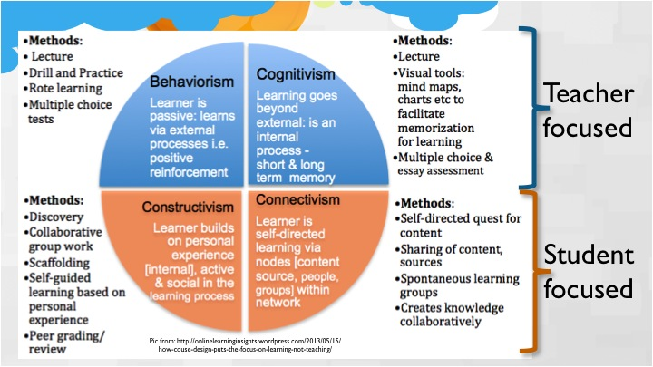

**Behaviorism**

Behaviorism theory of learning is a mechanical process of associating the stimulus with response, which produces a new behavior. Such behavior is strengthened by the reinforcement. Main proponents of this theory were J.B.Watson and I.Pavlov. Behaviorists view the learner as a passive person who responds to the stimuli. According to them the learner starts from a scratch (which means clean slate) and the behavior is shaped by the reinforcement. Positive as well as negative reinforcement increase the probability of the repetition of behavior. Where as the punishment decreases the chances of repetition of the behavior. Learning is therefore defined as a change in the behavior of the learner. Some critics say that it is an extrapolation of animal behavior to humans.

**Cognitivism**

Cognitivism refers to the study of the mind and how it obtains, processes, and stores information. This theory was an alternative to behaviorism. It was argued that not all learning occurs through shaping and changing of behaviors. In this theory, learners are active participants in their learning, and the mind functions like a computer processor. Information comes in as input, the mind processes the information for the time being, and the information is stored away to be retrieved later. Learning is shaped by acquired learning strategies and prior knowledge and attitudes, called schemas. The cognitive view of learning is teacher-centered, and information must be presented in an organized manner in order to achieve the most efficient learning.

Cognitivism is suited well for problem solving, where the concepts are complex and must be broken down into smaller parts. Ideas and concepts from these problems are linked to prior knowledge, which in turn helps the learner develop a stronger comprehension. However, Because learning is very structured, it may become difficult for learners to adapt to changes in what has already been processed and learned. When problems are broken down into smaller parts, learners are not overwhelmed with incoming information.

**Constructivism**

Constructivism is the study of a learner's own construction of knowledge. This knowledge is constructed through one's own personal experiences and interactions with the outside world. The learner takes in new information and gives meaning to it using his or her own prior attitudes, beliefs, and experiences as references. Learners are active participants in the construction of knowledge while the instructor serves as a facilitator. Two types of constructivism emerged beginning in the late 1970s. Lev Vygotsky introduced social constructivism, in which social interaction with others helps the learner put meaning to information. Vygotsky noted a Zone of Proximal Devleopment, in which learners can develop a certain level of meaning on their own but can grow even greater after interacting with classmates and instructors. In 1985, Jean Piaget introduced cognitive constructivism, in which knowledge is constructed by either assimilation or accommodation. In assimilation, incoming information is associated with a schema, and in accommodation, incoming information does not match a schema.

Constructivism is best utilized when learners take control of the learning situation, such as in Problem-Based Learning. As learners engage themselves in an activity like this, they develop an understanding of the importance of the problem, comprehend the relevance of the topic, and construct knowledge through their experiences. It is more important to focus on the whole rather than the individual parts in constructivist learning. Constructivism is sometimes misconstrued as a theory that compels students to reinvent the wheel, but instead, it implores students to attempt to learn how it functions and apply this to real-world learning.

Constructivist activities are generally relevant to the learner and real-world based. Learners construct knowledge and meaning as they can relate the information to their own experiences, beliefs, and attitudes. However Individual experiences and attitudes can vary. A specific, desired outcome may not always be achieved when different people approach the problem or task different ways.

**Connectivism**

Connectivism is a learning theory, in which knowledge exists outside of the learner (for example informations available library, internet, youtube, social networks), and the learner makes connections between information to build knowledge. The connections that learners make help them create their own learning network. Through this connected web, learners will be able to stay up-to-date with content as it changes. It is important for the learner to be able to identify credible resources. However, because so many sources exist, it can become difficult to determine if a source is legitimate or not.

## Higher order thinking skills

Whatever the learning theory adapted in the students life, graduate engineering attributes have to be developed by the engineering students in order to fulfill their aspirations to have good career or their to contribute to the society. These attributes are clearly related to higher order thinking skills, which build on more basic skills. The concept of higher order thinking skills was first introduced by an American educationist Benjamin Bloom in his Taxonomy of Educational Objectives (1956). In revised Bloom’s taxomomy there are three domains of educational activities or learning as follows:

* Cognitive: mental skills (knowledge)
* Affective: growth in feelings or emotional areas (attitude or self)
* Psychomotor: manual or physical skills (skills)

**Revised Cognitive Domain And Associated Complexity Levels**

**Highest**

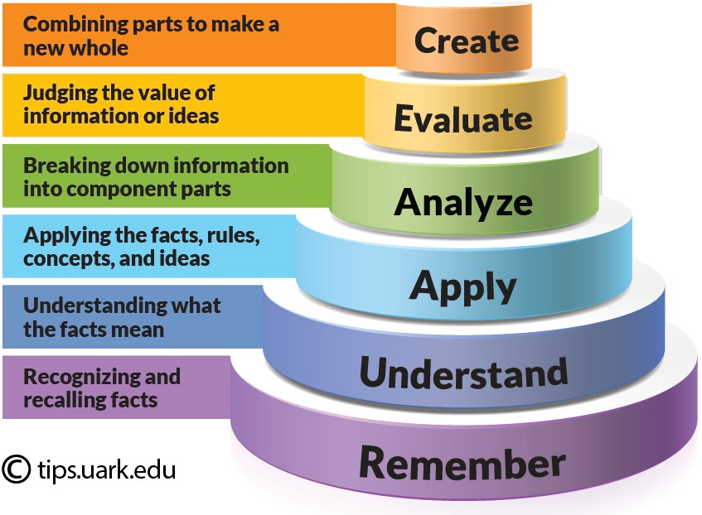

**Lower order thinking skills**

**Higher order thinking skills**

**Lowest**

**Affective Domain And Associated Complexity Levels**

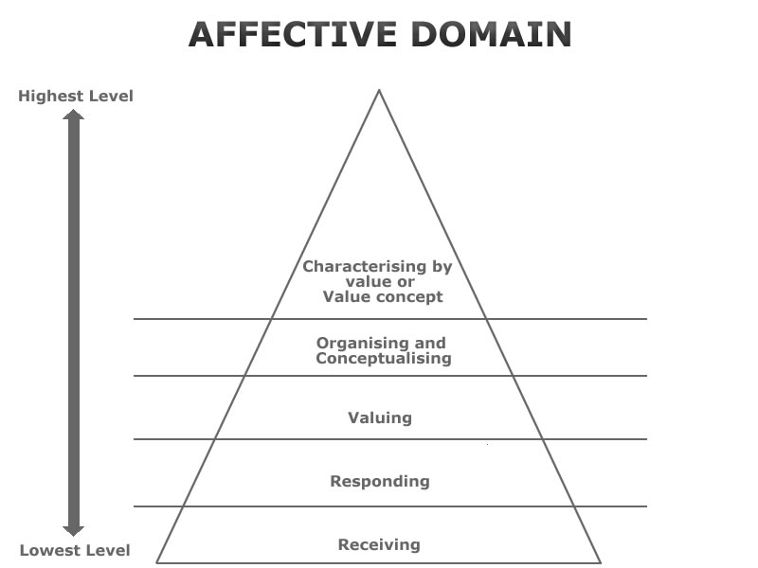

**Pshycomotor Domain And Associated Complexity Levels**

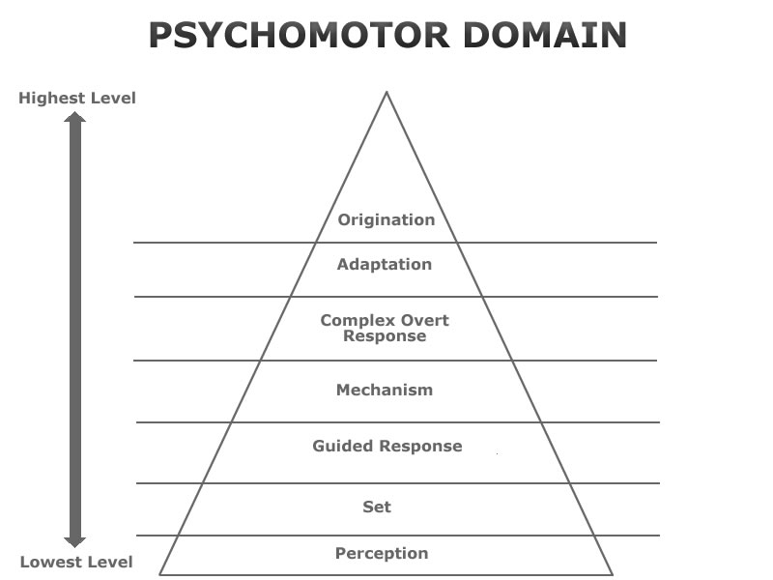

## multiple intelligences

The Theory of Multiple Intelligences is a theory of intelligence that differentiates it into specific (primarily sensory) "modalities", rather than seeing intelligence as dominated by a single general ability. This model was proposed by Howard Gardner in his 1983.

|  |  |  |
| --- | --- | --- |
|  | **INTELLIGENCE** | **DOMINANT SKILLS AND CAREER PREFERENCES** |
| 1 | **Verbal-Linguistic Intelligence**  Well-developed verbal skills and sensitivity to the sounds, meanings and rhythms of words | **Skills - Listening, speaking, writing, teaching.**  **Careers** - Poet, journalist, writer, teacher, lawyer, politician, translator |
| 2 | **Mathematical-Logical Intelligence**  Ability to think conceptually and abstractly, and capacity to discern logical or numerical patterns | **Skills** - Problem solving (logical & math), performing experiments  **Careers** - Scientists, engineers, accountants, mathematicians |
| 3 | **Musical Intelligence**  Ability to produce and appreciate rhythm, pitch and timber | **Skills** - Singing, playing instruments, composing music  **Careers** - Musician, disc jockey, singer, composer |
| 4 | **Visual-Spatial Intelligence**  Capacity to think in images and pictures, to visualize accurately and abstractly | **Skills** - puzzle building, painting, constructing, fixing, designing objects  **Careers** - Sculptor, artist, inventor, architect, mechanic, engineer |
| 5 | **Bodily-Kinesthetic** **Intelligence**  Ability to control one's body movements and to handle objects skillfully | **Skills** - Dancing, sports, hands on experiments, acting  **Careers** - Athlete, PE teacher, dancer, actor, firefighter |
| 6 | **Interpersonal Intelligence**  Capacity to detect and respond appropriately to the moods, motivations and desires of others | **Skills** - Seeing from other perspectives, empathy, counseling, co-operating  **Careers** - Counselor, salesperson, politician, business person, minister |
| 7 | **Intrapersonal Intelligence**  Capacity to be self-aware and in tune with inner feelings, values, beliefs and thinking processes | **Skills** - Recognize one’s S/W, reflective, aware of inner feelings  **Careers** - Researchers, theorists, philosophers |
| 8 | **Naturalist Intelligence**  Ability to recognize and categorize plants, animals and other objects in nature | **Skills** - Recognize one’s connection to nature, apply science theory to life  **Careers** – Scientist, naturalist, landscape architect, farmer |
| 9 | **Existential Intelligence**  Sensitivity and capacity to tackle deep questions about human existence, such as the meaning of life, why do we die, and how did we get here | **Skills** – Reflective and deep thinking, design abstract theories  **Careers** – Scientist, philosopher, theologian |

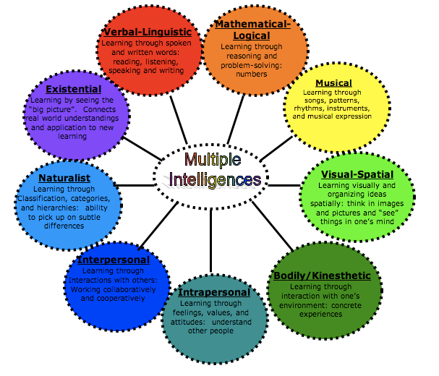

## learning styles inventory

As per the literature, there are more than 70 different learning styles models. Out of which David A. Kolb's model is popular which is based on his experiential learning model, as explained in his book “*Experiential Learning”.*

Kolb's model outlines two related approaches toward grasping experience: *Concrete Experience* and *Abstract Conceptualization*, as well as two related approaches toward transforming experience: *Reflective Observation* and *Active Experimentation*.

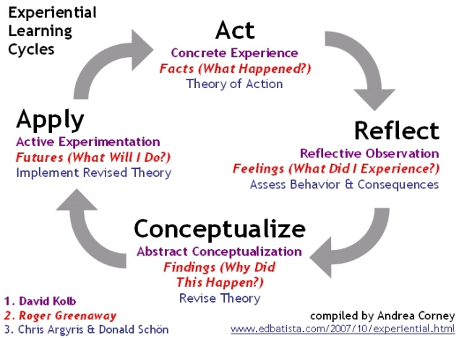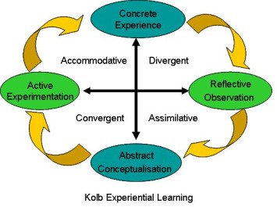

According to Kolb's model, the ideal learning process engages following all four of these modes in response to situational demands; they form a learning cycle from experience to observation to conceptualization to experimentation and back to experience. In order for learning to be effective, all four of these approaches must be incorporated. As individuals attempt to use all four approaches, however, they may tend to develop strengths in one experience-grasping approach and one experience-transforming approach, leading them to prefer one of the following four learning styles

Accommodator = Concrete Experience + Active Experiment: strong in "hands-on" practical doing (e.g., physical therapists)

Converger = Abstract Conceptualization + Active Experiment: strong in practical "hands-on" application of theories (e.g., engineers)

Diverger = Concrete Experience + Reflective Observation: strong in imaginative ability and discussion (e.g., social workers)

Assimilator = Abstract Conceptualization + Reflective Observation: strong in inductive reasoning and creation of theories (e.g., philosophers)

The Learning Style Inventory (LSI) is connected with David A. Kolb's model and is used to determine a student's learning style. Learning Style Inventory is a simple self description test that is designed to measure learners strengths and weaknesses. There are nine learning styles that are to questioned how students are : initiating, experiencing, imagining, reflecting, analyzing, thinking, deciding, acting, and balancing. The LSI is intended to help employees or students to "understand how their learning style impacts upon problem solving, teamwork, handling conflict, communication and career choice; develop more learning flexibility; find out why teams work well—or badly—together; strengthen their overall learning."

## teaching/ learning process and methodologies.

I will include this section in next release.