Dr. Mahalingam College of Engineering & Technology
Pollachi- 642003

CONTINUOUS ASSESSMENT TEST – II

Class & Branch : II B.E. - CIVIL Max. Marks : 50
Sub Name : APPLIED HYDRAULIC ENGINEERING Time : 1½ hrs
Semester : IV Date : 18-MAR-2010

PART – A (10 x 2 = 20 Marks)
Answer all questions :

- Distinguish alternate depth, critical depth, normal depth of flow.
There two depths possible for a given specific energy and hence these depths are called alternate depth to each other. But in case of critical flow (Fr=1) only one depth is possible for a given specific energy and that depth is called critical depth. Normal depth is the depth of flow in case of uniform flow.
- List the factors affecting mannings coefficient ‘n’?
Some important factors affecting manning’s coefficient are:
(a) surface roughness,
(b) vegetation,
(c) cross-section irregularity and
(d) irregularity alignment of channel.
- Define conveyance of the channel?
Conveyance is expressed as the discharge capacity of the channel per unit longitudinal slope. $K=\frac{Q}{\sqrt{S_{o}}}$
- What is the condition for hydraulically i) efficient and ii) most efficient trapezoidal channels?
With the slope, roughness coefficient and area of flow fixed, a minimum perimeter section will represent the hydraulically-efficient section as it conveys the maximum discharge.
Condition for Hydraulically efficient section: When area of section A and side slope m are fixed, the sum of side slope lengths of the cross-section should be equal to top width of the flow. Thus the proportions of a hydraulically efficient trapezoidal channel section will be such that a semi-circle can be inscribed in it.
Condition for Hydraulically most efficient section: Along with the above condition, m should be equal to 1/√3 ie. Side slope at 60° with the horizontal. Thus the hydraulically most efficient trapezoidal section becomes one-half of a regular hexagon.

- What is the critical slope in the case of uniform flow?
The slope of a channel which carries a given discharge as a uniform flow at the critical depth is called the critical slope
- What are the assumptions involved in the analysis of gradually varied flow
- The pressure distribution at any section is assumed to be hydrostatic.
- In the Uniform flow equation (Manning’s formula etc), energy slope can be used inlieu of bed slope in the analysis of GVF.
- Write the dynamic equation of GVF which involves geometry properties and discharge.
$$\frac{\text{dy}}{\text{dx}}=\frac{S_{0}−S_{f}}{1−\frac{Q^{2}T}{{\text{gA}}^{3}}}$$
Where dy/dx is slope of water profile at a section,
S_{o} is the bed slope at a section
S_{f} is the energy slope at a section
Q is the discharge
T is the flow width water surface
A is cross sectional area of flow
- Explain back water curves?

Obstructions to flow, such as weirs, Dams, structures and natural features, such as bends increase the depth of flow and make water surface not parallel to bed slope. The longitudinal profile of these kind of water surfaces (gradually varied flow) is called as back water curve.
- What are the possible profiles in a steep sloped open channel flow?
S1, S2 and S3 profiles.
All these profiles occur in the steep sloped channel.
S1 profile - The S1 profile is produced when the flow from a steep channel is obstructed by a weir or dam.
S2 profile - Profiles of the S2 type occur at a break of grade from mild slopes to steep slope.Generally S2 profiles are of short length.
S3 profile - Flow from a sluice gate with a steep slope on its downstream is of the S3 type. The S3 curve also results when a flow exists from a steeper slope to a less steep slope.

- What type of profile exists when a channel has break in grade from steep channel to a mild channel? Sketch the water profile
The S1 profile is produced when channel has break in grade from steep channel to a mild channel.
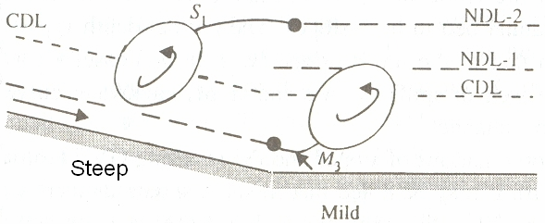

PART – B ( 3 x 10 = 30 Marks)
Answer any three of the following

- (a) Derive the Chezy’s formula from basic principle for uniform flow through open channel and compare it with manning’s formula. (5)
By definition there is no acceleration in uniform flow. By applying the momentum equation to a control volume encompassing sections 1 and 2, distance L apart, as shown in Fig. 3.1,
$P_{1}+W\text{sin}θ−F_{f}−P_{2}=M_{2}−M_{1}$. Eq(13.1)
where P1 and P2 are the pressure forces and M1 and M2 are the momentum fluxes at section 1 and 2 respectively. W = weight of fluid in the control volume and F_{f} = shear force at the boundary.
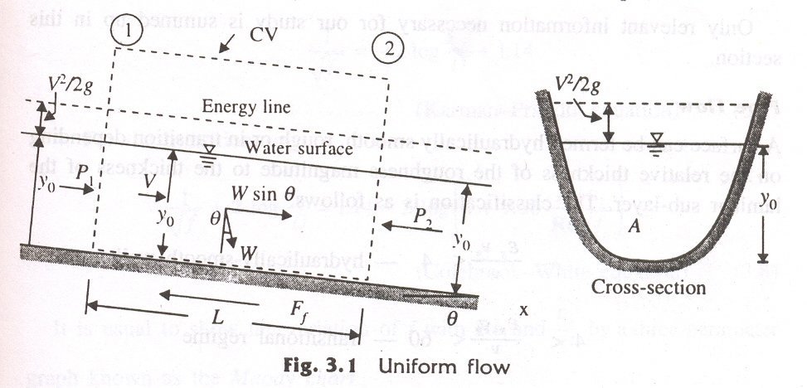
Since the flow is uniform, $P_{1}=P_{2} \text{and} M_{1}=M_{2}$
Also, $W=γ\text{AL} \text{and} F_{f}=τ_{0}\text{PL}$
where $τ_{0}$ = average shear stress on the wetted perimeter of length P and γ = unit weight of water. Replacing $\text{sin}θ$ by $S_{0}$(= bottom slope), Eq. (13.1) can be written as $γ{\text{ALS}}_{0}=τ_{0}\text{PL}$.
Or $τ_{0}=γ\frac{A}{P}S_{0}=γ{\text{RS}}_{0}$ Eq(13.2)
where R=A/P is defined as the hydraulic radius.
R is a length parameter accounting for the shape of the channel. It plays a very important role in developing flow equations which are common to all shapes of channels.
Expressing the average shear stress $τ_{0}$ as $τ_{0}={kρV}^{2}$.
where k is a coefficient which depends on the nature of the surface and flow parameters, Eq. (13.2) is written as
${kρV}^{2}=γ{\text{RS}}_{0}$ leading to $V=C\sqrt{{\text{RS}}_{0}}$. Eq(13.3)
where $C=\sqrt{\frac{γ}{ρ}\frac{1}{k}}$is a coefficient which depends on the nature of the surface and the flow. Equation (13.3) is known as the Chezy formula
When compared this equation with Manning’s formula $V=\frac{1}{n}R^{\frac{2}{3}}\sqrt{S_{o}}$,
$$V=C\sqrt{{\text{RS}}_{0}}=\frac{1}{n}R^{\frac{2}{3}}\sqrt{S_{o}}$$
$C=\frac{R^{\frac{1}{6}}}{n}$ where n is mannings coefficient.
(b) A concrete lined trapezoidal channel (n = 0.015) is 8 m wide and has a side slope of 2 horizontal : 1 vertical. The longitudinal; slope is 0.006. Estimate the normal depth in this channel for a discharge of 40 m3/s (5)
B=8m , Q = 40 m³/s, m=2
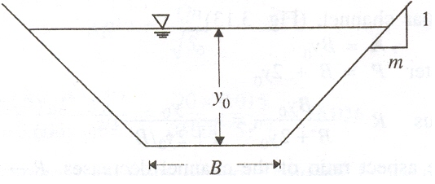
So = 0.006 and n=0.015.
Y_{o} = ?

According manning’s formula
$$Q=\frac{1}{n}A\text{.}R^{\frac{2}{3}}\sqrt{S_{o}}$$
Where Q is the discharge, A is the area of flow, R=A/P, P is the wetted perimeter. So, it can also be written as $Q=\frac{1}{n}\frac{A^{5/3}}{P^{2/3}}\sqrt{S_{o}}$
A= (8+2y_{o})y_{o} and $P=(8+2\sqrt{2^{2}+1} y_{o})$=(8+4.4721 y₀)
Substituting value of A, P, Q, n and So.
$$\text{40}=\frac{1}{0\text{.}\text{015}}\frac{(8+2y_{o})^{5/3}y_{o}^{5/3}}{(8+4\text{.}\text{4721}y_{o})^{2/3}}\sqrt{0\text{.}\text{006}}$$
$$\frac{(8+2y_{o})^{5/3}y_{o}^{5/3}}{(8+4\text{.}\text{4721}y_{o})^{2/3}}=7\text{.}\text{7460}$$
Solving the above equation, normal depth 0.9403 m

- A standard lined trapezoidal section to carry a discharge of 100 m³/s at a slope of 1:1000. The side slopes are to be 1.5 H : 1 vertical and the manning’s ‘n’ can be taken as 0.015. What bottom width is needed to have a full supply depth of 2.00m? (10)
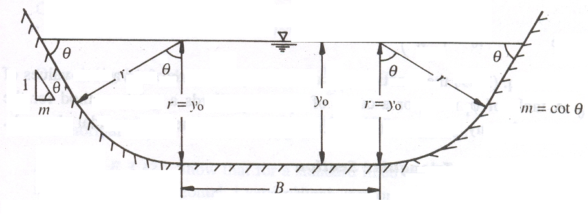
y₀=2.00m,
Q = 100 m³/s,
m=1.5, So = 0.001
and n=0.015.
B = ?

m = cotθ =1/tanθ
θ = arctan(1/m) = 0.5880 Rad
ε = m+θ = 1.5+0.5880 = 2.0880
A = $B×y_{0}+2×\left(\frac{π×y_{0}^{2}}{2π}θ\right)+2×\left(y_{0}\frac{y_{0}}{\text{tan}θ}\right)=B×y_{0}+y_{0}^{2}θ+2×\left(\frac{y_{0}\frac{y_{0}}{\text{tan}θ}}{2}\right)$
=$\left[B+y_{0}θ+\frac{y_{0}}{\text{tan}θ}\right]y_{0}=\left[B+y_{0}(θ+m)\right]y_{0}$
Hence A = (B+2.0880 * 2)*2 = 2B+8.352
P = $B+2y_{0}θ+2×\left(\frac{y_{0}}{\text{tan}θ}\right)=B+2y_{0}\left(\frac{1}{\text{tan}θ}+θ\right)=B+2y_{0}\left(m+θ\right)$
P=B+2*2*2.0880=B+8.352
From manning’s formula, We know that,
$$\frac{A^{5/3}}{P^{2/3}}=\frac{\text{nQ}}{\sqrt{S_{o}}}$$
$$\frac{(2B+8\text{.}\text{352})^{5/3}}{(B+8\text{.}\text{352})^{2/3}}=\frac{0\text{.}\text{015}∗\text{100}}{\sqrt{0\text{.}\text{001}}}$$
$$\frac{(2B+8\text{.}\text{352})^{5/3}}{(B+8\text{.}\text{352})^{2/3}}=\text{47}\text{.}\text{4342}$$
Solving this, we get,
B= 13.0864m
- The compound section shown in fig. 1. Assume n=0.02 and S_{o} = 0.0009 for all parts of the perimeter. Find the discharge a) using Posey’s method, b) Zero shear method c) Total section method. (10)
10.0 m
10.0 m
5.0 m
3.0 m
1.5 m
1.5 : 1
1.5 : 1
1 : 1
1 : 1

In total section method, the discharge is calculated by considering the whole section as one unit.
In the zero-shear method, actual area and actual perimeter of the each portion of the channel to compute the partial discharge. Then discharge is calculated as sum of all the partial discharges.
In the case of Posey’s method, imaginary shear interfaces are accounted in calculating perimeter for deep portion only.
Area A1 = A3 = 1.5 *[10 + (10+1.5*1.5)]/2=16.6875 m²
Actual perimeter P1 = P3 = 10+sqrt(1.5^2+1)*1.5=12.7042 m
Area A1 = 3*(5 + 3) + 11*1.5=40.5 m²
Actual perimeter P2 = 5+2*sqrt(2)*3=13.4853 m
Perimeter with imaginary shear interface = 13.4853+3=16.4853 m

section | Area | Perimeter | Perimeter for Posey’s method
1 | 16.6875 m² | 12.7042 m | 12.7042 m
2 | 40.5 m² | 13.4853 m | 16.4853 m
3 | 16.6875 m² | 12.7042 m | 12.7042 m
Total area = 2*16.6875+40.5 = 73.8750 m²
Total perimeter = 2*12.7042+13.4853 = 38.8937m
Discharge by Total section method
Q = 1/0.02*(73.875^(5/3)/38.8937^(2/3))*sqrt(0.0009)
Q_{w}= 169.955m³/s
Discharge by zero shear method
Q1 =Q3 = 1/0.02*(16.6875^(5/3)/12.7042^(2/3))*sqrt(0.0009)
Q1=30.022 m³/s
Q2 = 1/0.02*(40.5^(5/3)/13.4853^(2/3))*sqrt(0.0009)
Q1=126.457m³/s
Total Q = Q1 + Q2 + Q3 = 2*30.022 + 126.457 = 186.501 m³/s
Discharge by Posey’s method
Q1 =Q3 = 1/0.02*(16.6875^(5/3)/12.7042^(2/3))*sqrt(0.0009)
Q1=30.022 m³/s
Q2 = 1/0.02*(40.5^(5/3)/ 16.4853^(2/3))*sqrt(0.0009)
Q1=110.608 m³/s
Total Q = Q1 + Q2 + Q3 = 2*30.022 +110.608 = 170.652 m³/s

- How surface profiles of Gradually Varied Flow are classified and explain them with sketches. (10)
Classification of GVF water surface profiles.
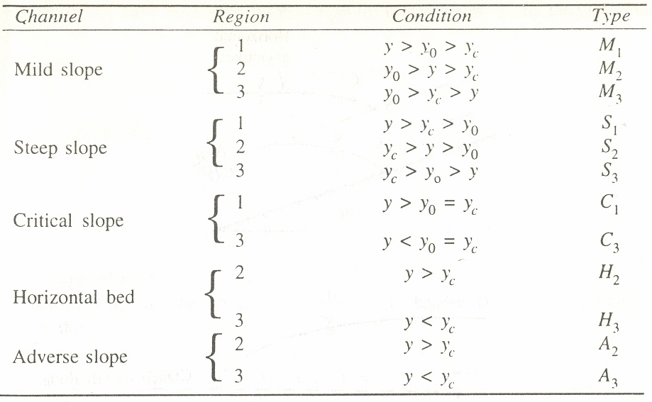
(a) Type M Profiles

The most common of all GVF profiles M1 type, which is a subcritical-flow condition. Obstructions to flow, such as weirs, Dams, structures and natural features, such as bends, produce M1 backwater curves.
The M2 profiles occur at a sudden drop in bed of the channel, at constriction type of transitions and at the canal outlet into pools
The M3 type of profile occurs where a supercritical stream enters a mild- slop channel. The flow leading from a Spillway or sluice gate to a mild slope forms a typical example

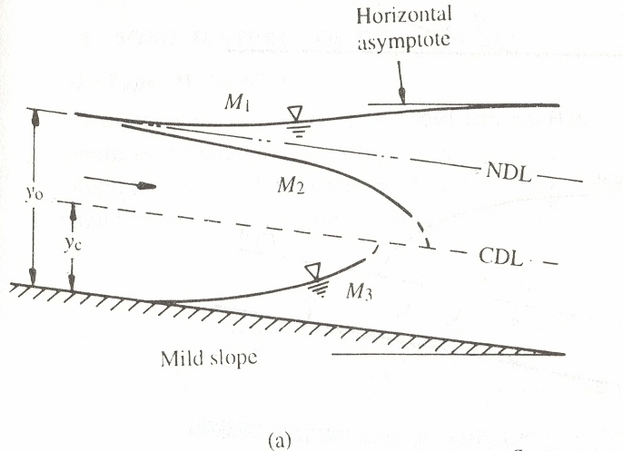
(b) Type S Profiles
The S1 profile is produced when the flow from a steep channel is terminated by a deep pool created by an obstruction, such as a weir or dam. At the beginning of the curve, the flow changes from the normal depth (supercritical flow) to subcritical flow through a hydraulic jump.
Profiles of the S2 type occur at the entrance region of a steep channel leading from a reservoir and at a break of grade from mild slopes to steep slope. Generally S2 profiles are of short length.
Flow profile from a sluice gate with a steep slope on its downstream is of the S3 type. The S3 curve also results when a flow exists from a steeper slope to a less steep slope

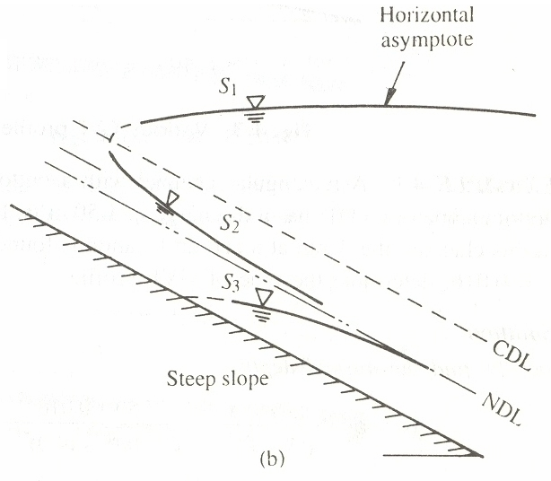

(c) Type C Profiles
C1 and C3 profiles are very rare and are highly unstable.

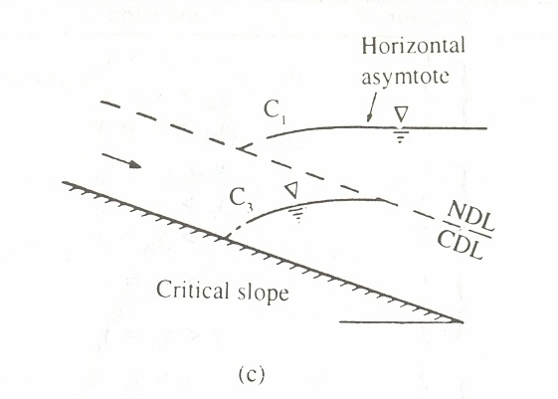

(d) Type H Profiles
A horizontal channel can be considered as the lower limit reached by a mild slope as its bed slope becomes flatter. It is obvious that there is no region 1 for a horizontal channel as yo → ∞. The H2 and H3 profiles are similar to M2 and M2 profiles respectively.

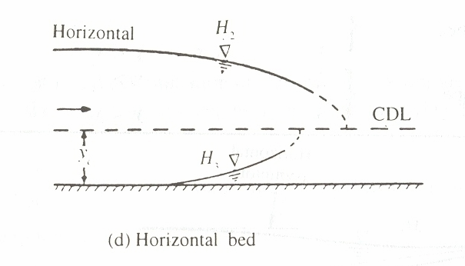

(e) Type A Profiles
Adverse slopes are rather rare and A2 and A3 curves are similar to H2 and H3 curves respectively. These profiles are of very short length.

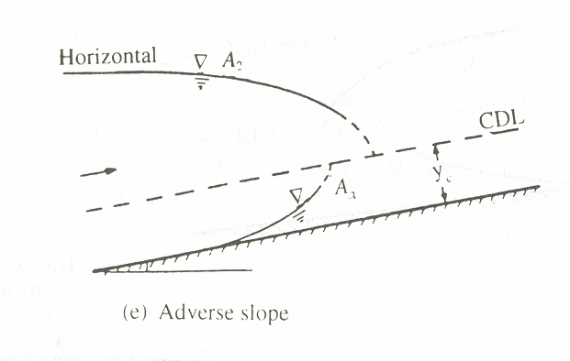
- A rectangular channel has three reaches A, B, C connected in series in the same order with the following geometric properties:
Reach | Bed Width B | Bed slope S_{o} | n
A | 4 | 0.001 | 0.015
B | 4 | 0.009 | 0.012
C | 4 | 0.006 | 0.015
For a discharge of 23 m³/s through this channel, sketch the resulting water-surface profiles. The length of the reaches can be assumed to be sufficiently long for the GVF profiles to develop fully. (10)
Critical depth y_{c} = (Q^2/(g*B^2))^(1/3) = (23^2/ (9.81*4^2))^(1/3) = 1.4993 m
This y_{c} is applicable for all reaches. But yo is different for each reach.
For uniform flow, A^(5/3)/P^(2/3)=Q n /Sqrt(so)
This reduces for rectangular channel to
(By)^5/3/(B+2*y)^(2/3)=Q n / sqrt(so),
In this problem,
10.0794y^(5/3)/(4+2y)^(2/3)=23*n/sqrt(so)
For reach A
10.0794y₀^(5/3)/(4+2y₀)^(2/3)=23*0.015/sqrt(0.001)
Solving we get y_{0A} = 2.5327 m
For reach B
10.0794y₀^(5/3)/(4+2y₀)^(2/3)=23*0.012/sqrt(0.009)
Solving we get y_{0B} = 0.9673 m
For reach C
10.0794y₀^(5/3)/(4+2y₀)^(2/3)=23*0.015/sqrt(0.006)
Solving we get y_{0B} = 1.3037 m
