Dr. Mahalingam College of Engineering & Technology
Pollachi- 642003

CONTINUOUS ASSESSMENT TEST – I – Questions and answers

Class & Branch : II B.E. - CIVIL Max. Marks : 50
Sub. Code & Name : APPLIED HYDRAULIC ENGINEERING Time : 1½ hrs
Semester : IV Test Date : 26-FEB-2009
Answers released Date : 27-FEB-2009

PART – A (10 x 2 = 20 Marks)
Answer all questions :

- Define open channel flow.
The flow in an open channel or in a closed conduit having a free surface is referred to as free-surface flow or open-channel flow. The free surface is usually subjected to atmospheric pressure.

- Differentiate pipe flow and open channel flow?
Differences between pipe and open channel flow of incompressible fluid
 | PIPE FLOW | OPEN CHANNEL FLOW
Flow driven by | Pressure | Gravity (i.e. potential energy)
Flow cross-section | Known (fixed by pipe geometry) | Unknown in advance because the flow depth is unknown beforehand.
Characteristic flow parameters | Velocity deduced from continuity equation | Flow depth and velocity deduced by solving simultaneously the continuity and momentum equations
Specific boundary conditions |  | Atmospheric pressure at the flow free surface

- Give an example with sketch for each type of channel.
Prismatic channels - Cross sectional shape and size and also the bottom longitudinal slope along the length of the channel are constant.

Rectangular
Trapezoidal

Non-Prismatic Channels - Natural channels generally have varying cross-sections and hence are called non-prismatic channels.

A stream
Varying cross-section

Rigid channels- Rigid channels geometry and roughness are essentially constant with time. Eg. Lined canals

Man-made Non-Erodable

Mobile boundary channels - Geometry of natural rivers, streams etc, undergo deformation over the period of time.

Natural stream – Erodable bed

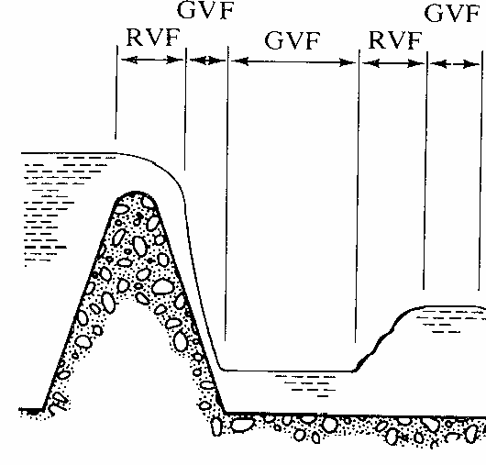
- Give an example for Steady uniform flow, steady GVF, steady RVF and steady SVF with neat sketches.
Varied flow – GVF & RVF
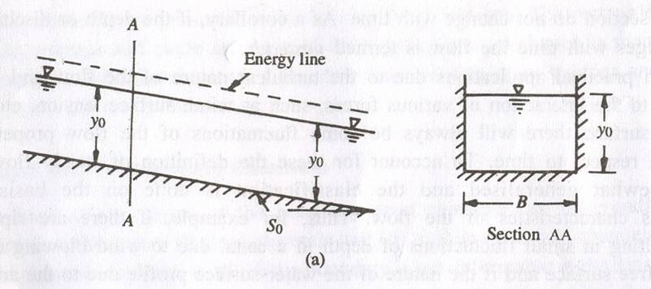
Uniform flow
B
B

and section BB, at all time

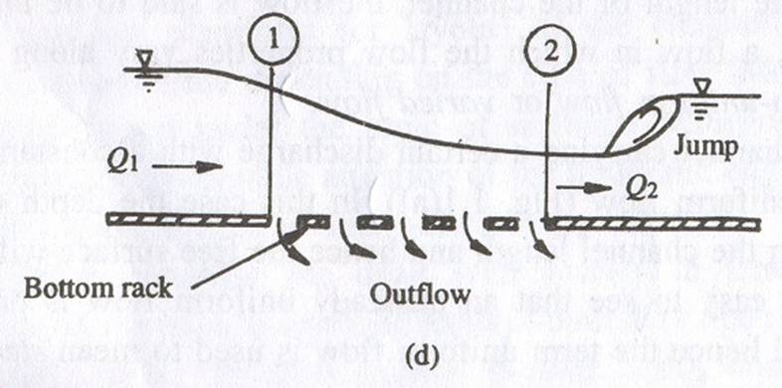
Spatially varied flow

- Differentiate uniform and varied flows.
If the flow velocity at a given instant of time does not vary within a given length of channel, then the flow is called uniform flow. However, if the flow velocity at a time varies with respect to distance, then the flow is called non-uniform flow, or varied flow.

- Define Froude number and classify the flows in open channel based on this number.
In the channel flow, Froude number is defined as Fr=V/√(g*A/T) where V is the flow velocity, A is the area of flow and T is the width of the flow at the surface.
The flow in a channel is called critical flow if the Fr =1. If Fr <1, flow is called sub-critical flow. If Fr >1, the flow is called super-critical flow.

- What is the need of kinetic energy correction factor α and momentum correction factor β? What would be value of α and β in the case of uniform flow?
The mean velocity has been used to represent for the entire section to simplify the flow analysis. The sum of kinetic energy flux for a cross-section arrived from the velocity components in the longitudinal direction will not be equal to the kinetic energy flux calculated based on the mean velocity V. So, a correction factor α is needed to utilize only the mean velocity (without using the all velocities in the cross-section) in arriving the correct K.E. In the case of momentum correction factor β, momentum flux has to be corrected for the same reason. Both values will be 1 for uniform flow.
- What is effective piezometric head h_{ep}?
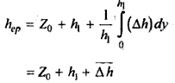
If the pressure head variation is non-linear with the depth, the effective piezometric head is calculated to represent ($\frac{P}{γ}+h$) for the entire cross section in 1D analysis and is defined as

- Define specific force.
Specific force Ps is the sum of the pressure force and momentum flux per unit weight of the fluid at a section.
Ps = (F+M)/γ

- Find the critical depth of a rectangular channel carrying a discharge of 2.4 m³/s/m.
$$y_{c}={\left(\frac{q^{2}}{g}\right)}^{1/3}={\left(\frac{2\text{.}4^{2}}{9\text{.}\text{81}}\right)}^{1/3}=0\text{.}\text{8374m}$$

PART – B ( 3 x 10 = 30 Marks)
Answer any three of the following

- a) Classify the open channel flows with neat sketches (5)
FLOW
STEADY
UNSTEADY
UNIFORM
VARIED
VARIED
GRADUAL (GVF)
RAPID (RVF)
SPATIAL (SVF)
GRADUAL (GVUF)
RAPID (RVUF)
SPATIAL(SVUF)
UNIFORM

Steady and Unsteady Flows
This classification is based on the time variation of velocity v at a specified location. If the flow velocity (and other parameters like, discharge, flow depth etc.) at a given point or section does not change with respect to time, then the flow is called steady flow. Thus, the local acceleration, ∂v/∂t, is zero in steady flows. In two- or three-dimensional steady flows, the time variation of all components of velocity is zero.
If the velocity (and other parameters like, discharge, flow depth etc.) at a given location changes with respect to time, then the flow is called unsteady flow.
Uniform and Nonuniform (Varied) flows
This classification is based on the variation of flow velocity with respect to space at a specified instant of time.
If the flow velocity at a given instant of time does not vary within a given length of channel, then the flow is called uniform flow. However, if the flow velocity at a time varies with respect to distance, then the flow is called non-uniform flow, or varied flow.
Varied Flow
Depending upon the rate of variation with respect to distance, flows may be classified as gradually varied flow or rapidly varied flow. As the name implies, the flow is called gradually varied flow, if the flow depth varies at a slow rate with respect to distance, whereas the flow is called rapidly varied flow if the flow depth varies significantly in a short distance. Frictional resistance is significant in GVF. Frictional resistance is insignificant in GVF.
Examples: GVF = backing of water in a stream due to dam
GVUF = Passage of flood wave in a river
RVF = hydraulic jump occurring below a spillway or a sluice gate.
RVUF = surge – bore/tide travelling up a river.
Spatially varied Flow (SVF or SVUF)
When some flow is added or discharged from the flow system, then resulting varied flow is known as spatially varied flow. SVF can be steady (SVF) or unsteady (SVUF).
Example : SVF = Flow over bottom rack
SVUF = Runoff due to rainfall
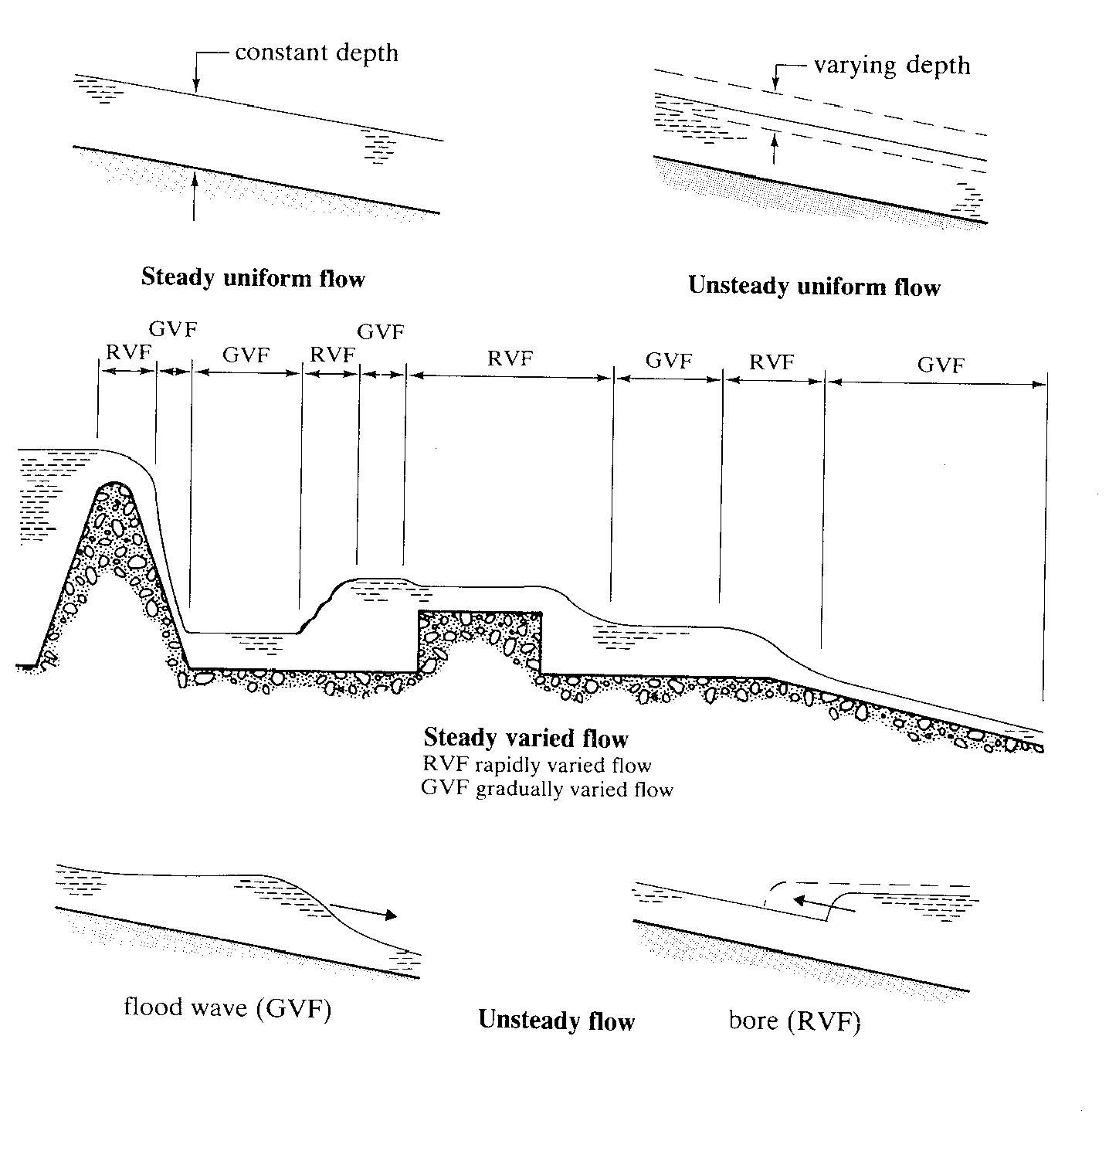

b) Determine the force per m width of the sluice gate when the flow is steady. All the necessary details are given in the figure 1. Assume no loss. (5)
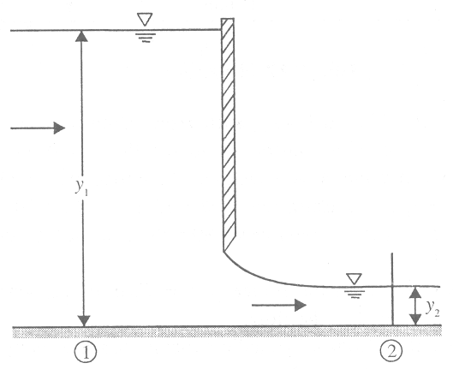
q
q
3.0 m
0.25 m
Figure 1
F1
F2
Fs

Major steps:
a. Find q from energy equation.
b. Find force on the sluice gate using momentum equation.

From energy equation, Energy at section (1) is equal to energy at section (2), under no loss condition.
So, considering bed as datum,
$$0+y_{1}+\frac{q^{2}}{2{\text{gy}}_{1}^{2}}=0+y_{2}+\frac{q^{2}}{2{\text{gy}}_{2}^{2}}$$

$$\frac{q^{2}}{2g}\left(\frac{1}{y_{1}^{2}}−\frac{1}{y_{2}^{2}}\right)=y_{2}−y_{1}$$
$$q=\sqrt{\frac{2g(y_{2}−y_{1})}{\left(\frac{1}{y_{1}^{2}}−\frac{1}{y_{2}^{2}}\right)}}=\sqrt{\frac{2x9\text{.}\text{81}(0\text{.}\text{25}−3\text{.}0)}{\left(\frac{1}{3\text{.}0^{2}}−\frac{1}{0\text{.}{\text{25}}^{2}}\right)}}=1\text{.}{{{\text{8428 m}}^{3}}/s}/m$$

Momentum equation is
$F_{1}−F_{2}−F_{s}=M_{2}−M_{1}$ ; Forces are marked in the figure at appropriate places.
In this case, momentum equation becomes
$$\frac{ρ{\text{gy}}_{1}^{2}}{2}−\frac{ρ{\text{gy}}_{2}^{2}}{2}−F_{s}=ρq\left(\frac{q}{y_{2}}−\frac{q}{y_{1}}\right)$$
$$F_{s}=\frac{ρg(y_{1}^{2}−y_{2}^{2})}{2}−{ρq}^{2}\left(\frac{1}{y_{2}}−\frac{1}{y_{1}}\right)=\frac{\text{9810}(3\text{.}0^{2}−0\text{.}{\text{25}}^{2})}{2}−\text{1000}∗1\text{.}{\text{8428}}^{2}\left(\frac{1}{0\text{.}\text{25}}−\frac{1}{3\text{.}0}\right)$$
$$F_{s}=\text{31}\text{.}\text{387}\text{KN}$$

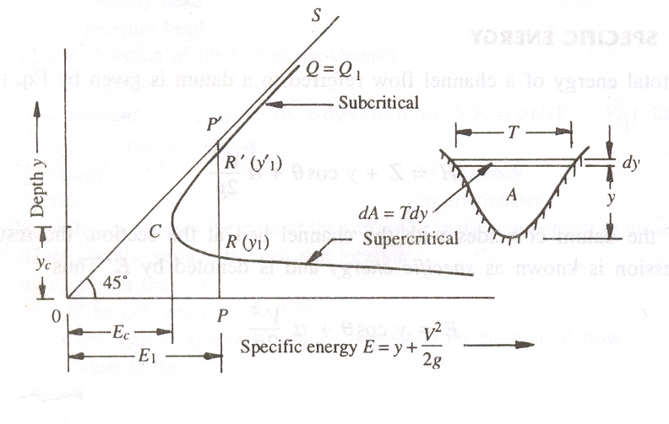
- Derive the condition for maximum discharge in a channel for a given specific energy. (10)
$E=y+\frac{Q^{2}}{2{\text{gA}}^{2}} (\text{Eq 12}\text{.}1)$Specific energy for the given discharge is

After rearranging, Q can be explicitly written as
$Q/A=\sqrt{2g\left(E−y\right)} (\text{Eq}\text{.}\text{ 12}\text{.}2)$
$Q=A\sqrt{2g\left(E−y\right)} (\text{Eq}\text{.}\text{ 12}\text{.}3)$

The condition for maximum-discharge can be obtained by differentiating the above Eq. with respect to y and equating it to zero while keeping E as constant (means for given specific energy).
$\frac{\text{dQ}}{\text{dy}}=\sqrt{2g\left(E−y\right)}\frac{\text{dA}}{\text{dy}}−\frac{\text{gA}}{\sqrt{2g\left(E−y\right)}}=0 (\text{Eq}\text{.}\text{ 12}\text{.}4)$

$\frac{\text{dA}}{\text{dy}}=T$
From the figure above, , substituting, the above equation (12.4) becomes
$\frac{\text{dQ}}{\text{dy}}=\sqrt{2g\left(E−y\right)}T−\frac{\text{gA}}{\sqrt{2g\left(E−y\right)}}=0 (\text{Eq}\text{.}\text{ 12}\text{.}5)$

$\sqrt{2g\left(E−y\right)}$
$\frac{Q}{A}T−\frac{\text{gA}}{Q/A}=0$$\frac{Q}{A}T−\frac{{\text{gA}}^{2}}{Q}=0$Now, Substituting Q/A for , which was obtained above (Eq. 12.2), in the Eq. 12.5, the following can be obtained:

Multiplying with QA and dividing by g and rearranging terms, the condition for maximum discharge is obtained as
OR OR
- A trapezoidal channel has a bottom width 6 m and side slope of 2 horizontal to 1 vertical. If the depth of flow is 1.2 m at a discharge of 10 m³/s. Compute the specific energy and critical depth. (10)
6m
Side slope m=2. Q=10m³/s
y=1.2m

Specific Energy $E=y+\frac{Q^{2}}{2{\text{gA}}^{2}}$
From Given Data: A = (B+my)*y = (6+2*1.2)*1.2=10.08 m²
So , $E=1\text{.}2+\frac{{\text{10}}^{2}}{2×9\text{.}\text{81}×\text{10}\text{.}{\text{08}}^{2}}$=1.2502 m
Critical flow condition $\frac{Q^{2}}{g}=\frac{A_{c}^{3}}{T_{c}}$ (Eq 13.3)
$E_{c}=y_{c}+\frac{A_{c}}{2T_{c}}$ (Eq. 13.4) where $y_{c}$ is the critical flow depth, $T_{c}$ is the width at the flow surface when the flow is critical and $A_{c}$is the area of the flow when depth is $y_{c}$
$A_{c}=({\text{By}}_{c}+{\text{my}}_{c}^{2})$ and $T_{c}=(B+2{\text{my}}_{c})$
Hence Eq (13.3) becomes, $\frac{Q^{2}}{g}=\frac{(6y_{c}+2y_{c}^{2})^{3}}{(6+2×2×y_{c})}$
Solving the above equation we get the following 6 values for critical depth.
-3.3495-0.5255i , [-3.3495+0.5255i], [ -0.3034-0.6163i], [-0.3034+0.6163i],
[-2.3055], [0.6113]
Out of 6 values only one has the positive value. So 0.6113 is the critical depth.
So the positive root is the critical flow depth.
Hence for the given flow, critical flow depth yc = 0.6113m
- The rectangular channel carries a discharge of 30 m³/s. The bottom width of the channel is 6.0 m and flow velocity is 1.75 m/s. Determine two alternate depth possible in the channel. (10)
Q=30m³/s
V=1.75 m/s

6m
Given: Q=30m³/s
V=1.75 m/s
B = 6.0 m

Given discharge and the velocity are sufficient to find the flow depth.
ie. Q = AV ➔ Q = B*y * V ➔ y = Q/(BV) = 30/(6*1.75) =2.8571 m

Specific energy for the flow is
$E=y+\frac{Q^{2}}{2{\text{gB}}^{2}y^{2}}$ = 2.8571 + 30²/(2*9.81*36*2.8571²)=3.0132 m
Alternate depth can be found for the given specific energy.
$$3\text{.}\text{0132}=y+\frac{{\text{30}}^{2}}{2×9\text{.}\text{81}×6^{2}y^{2}}$$
$$3\text{.}\text{0132}=y+\frac{1\text{.}\text{2742}}{y^{2}}$$
Multiplying both sides by y² and rearranging terms, the following cubic equation is obtained.
$$y^{3}−3\text{.}\text{0132}y^{2}+1\text{.}\text{2742}=0$$
Solving this cubic equation, the following three values are obtained for y
1). -0.5943 , 2) 2.8571 and 2) 0.7504.
Negative value is practically not possible. So first value not our solution.
The specific energy is actually obtained for the flow depth y=2.8571. So this is already known. The third value 0.7504 is the alternate depth for the given flow.
0.7504m and 2.8571 m are the possible alternate flow depths for the given flow.

- A rectangular channel has a width of 4.0 m and carries a discharge of 20 m³/s with a depth of 2.0 m. if the hump is built for the height of 0.33m, calculate the water surface at upstream of the hump and over the hump. Neglect the energy loss. (10)
0.33m
Hump
E₁
E₂
2.0m
y₂
1
1
2
2
Q=20m³/s
B=4.0 m

q = 20/4 = 5 m³/s/m

Specific Energy at section (1)$E_{1}=y_{1}+\frac{q^{2}}{2{\text{gy}}_{1}^{2}}=2+\frac{5^{2}}{2×9\text{.}\text{81}×2^{2}}=2\text{.}\text{3186}$

Specific Energy at section (2)$E_{2}=E_{1}−ΔZ=2\text{.}\text{3186}−0\text{.}\text{33}=1\text{.}\text{9886}m$
Critical depth for the given flow in the rectangular channel is
$$y_{c}={\left(\frac{q^{2}}{g}\right)}^{\frac{1}{3}}={\left(\frac{5^{2}}{9\text{.}\text{81}}\right)}^{\frac{1}{3}}=1\text{.}\text{3659 m}$$
Minimum specific energy corresponding to the critical depth is
$$y_{c}={\left(\frac{q^{2}}{g}\right)}^{\frac{1}{3}}={\left(\frac{5^{2}}{9\text{.}\text{81}}\right)}^{\frac{1}{3}}=1\text{.}\text{3659 m}$$
At section (2), to pass the given flow, minimum energy required is Ec which higher than E2. So flow over the hump reaches critical condition.

yc=1.3659 m is the flow depth over the hump.

Since, critical condition is reached over the hump, this affects the flow depth section (1) Minimum required specific energy at section (1) is recalculated as
$$E_{1}^{1}=E_{c}+ΔZ=2\text{.}\text{0489}+0\text{.}\text{33}=2\text{.}\text{3789}m$$
It can be found that required energy $E_{1}^{1}=2\text{.}\text{3789}m$ is more than available energy $E_{1}=2\text{.}\text{3186}$. Hence flow depth is affected at upstream which can be found by solving the following equation.
$E_{1}^{'}=y_{1}^{'}+\frac{q^{2}}{2g(y_{1}^{'})^{2}}$➔ $2\text{.}\text{3789}=y_{1}^{'}+\frac{5^{2}}{2×9\text{.}\text{81}(y_{1}^{'})^{2}}$
$$2\text{.}\text{3789}=y_{1}^{'}+\frac{1\text{.}\text{2742}}{(y_{1}^{'})^{2}}$$
Multiplying both sides by $(y_{1}^{'})^{2}$ and rearranging terms, the following cubic equation is obtained.
$$(y_{1}^{'})^{3}−2\text{.}\text{3789}(y_{1}^{'})^{2}+1\text{.}\text{2742}=0$$
Solving this cubic equation, the following three values are obtained for $y_{1}^{'}$
1.) -0.6487
2.) 0.9415
3.) 2.0861
To select the right solution, Froude number for the initial flow at the upstream has to be obtained to check whether the flow is sub-critical or super-critical.
$$\text{Fr}=\frac{V}{\sqrt{{\text{gA}}/T}}=\frac{Q}{A\sqrt{{\text{gA}}/T}}=\frac{Q}{\sqrt{{{\text{gA}}^{3}}/T}}=\frac{\text{20}}{\sqrt{9\text{.}{\text{81}×6^{3}×2^{3}}/6}}=0\text{.}\text{3763}$$
Froude number is less than 1, so flow is sub-critical. So among the obtained solution, the highest positive solution is our answer for the flow depth at upstream.
So $y_{1}^{'}$=2.0861m

Flow depth at upstream $y_{1}^{'}$=2.0861m
Flow depth over the hump $y_{1}^{'}$= yc=1.3659 m

