**Dr. Mahalingam College of Engineering and Technology, Pollachi.**

(An Autonomous Institution affiliated to Anna University , Chennai)

**Continuous Comprehensive EvaluationTest-I – Key**

**11CE503 – STRUCTURAL ANALYSIS-I**

B.E. (CIVIL ENGINEERING)

Semester: V Date: 21.08.2012 Duration: 3 hours Maximum Marks: 75

**Section – A Objective Questions (15x1=15 Marks)**

1. If there are ‘m’ members, ‘r’ unknown reaction components and ‘j’ number of joints in the pin-jointed plane frame, then the degree of static indeterminacy is:

A). m + r + 2j B). m - r + 2j, C). m + r - 2j, D). m + r - 3j **[Ans: C]**

2. A plane truss having ‘m’ members, ‘j’ joints and r external reactions, will be unstable if

A). (m + r)<2j B). m + r = 2j C). (m + r)>2j D). none of the above **[Ans: C]**

3. Number of unknown internal forces in each member of a rigid jointed plane frame is______. **[Ans: 3]**

4. Degree of static indeterminacy of a rigid-jointed plane frame having 15 members, 3 reaction components and 14 joints is______.

A). 2 B). 3 C). 6 D). 8 **[Ans: C]**

5. In a space truss which has ‘j’ number of joints and ‘r’ external reactions then, the degree of kinematic indeterminacy is

A). 2j-r B). 3j-r C). j-2r D). j-3r **[Ans: B]**

6. The number of independent joint displacements which are to be determined in the structure is called

A). Degree of static Indeterminacy B). Degree of kinematic indeterminacy C). External indeterminacy D). Internal indeterminacy **[Ans: B]**

7. Principle of superposition is applicable for non-linear systems. (True/False) **[Ans: False]**

8. A work done by a real force acting through a virtual displacement or a virtual force acting through a real displacement is called _______.**[Ans: Virtual work]**.

9. The deflection at any point of a perfect frame can be obtained by applying a unit load at the joint in

A). vertical direction B). horizontal direction C). any inclined direction D). the direction in which the unit load is required. **[Ans: D]**

10. Virtual work Method is also referred as

A). Castigliano’s theorem B).Mohr’s theorem

C).Unit load method D). Macaulay’s method **[Ans: C]**

11. Change in temperature in a determinate structure will not affect stresses in the members.(True/False) **[Ans: True]**

12. A single rolling load of 8 kN rolls along a girder of 15 m span. The absolute maximum bending moment will be _______ kN.m **[Ans: 30kN.m]**

13. The maximum bending moment due to a train of wheel loads on a simply supported girder

A). always occurs at center of span B). always occurs under the critical wheel load C). never occurs under a wheel load D). none of the above **[Ans: B]**

14. When an uniformly distributed load, shorter than the span of the girder, moves from left to right, then the conditions for maximum bending moment at a section is that

A). the head of the load reaches the section

B). the tail of the load reaches the section

C). the load position should be such that the section divides it equally on both sides

D). the load position should be such that the section divides the load in the same ratio as it divides the span **[Ans:D]**

15. When a series of wheel loads crosses a simply supported girder, the maximum bending moment under any given wheel load occurs when

A). the center of gravity of the load system is midway between the center of span and wheel load under consideration

B). the center of span is midway between the center of gravity of the load system and the wheel load under consideration

C). the wheel load under consideration is midway between the center of span and the center of gravity of the load system

D). none of the above **[Ans: B]**

**Section – B Short Answer Questions (5x2=10 Marks)**

16. Distinguish between plane truss and plane frame.

**Ans: A plane truss is an articulated structure consisting members in a plane, pin jointed at their ends and carry axial forces only.**

**A plane frame is a structure consisting members in a plane, rigid jointed at their ends and carry bending moments, shear forces and axial forces.**

17. What is material non-linearity?

**Ans: Materials loaded beyond proportional limit, stress will not be proportional to strain even in the metallic materials because stress-strain relationship is not linear beyond that limit. When materials, such as soil, concrete, rubbery materials exhibiting non-linear stress-strain relationship or stressed beyond proportional limit, linear analysis will not yield accurate results. This kind of non linearity is due to the nature of material and hence it is called material non-linearity. Hence, non-linear analysis has to be employed to arrive accurate results.**

18. Define statically indeterminate structure.

**Ans: A structure is called statically indeterminate (or hyperstatic) structure when the static equilibrium equations are insufficient for determining the internal forces and reactions on that structure.**

19. State principle of virtual work

**Ans: The principle of virtual work can be stated ad follows:**

**If a deformable body in equilibrium is subjected to arbitrary virtual displacements associated with a compatibility condition, the virtual work done by the external forces on the body will be equal to virtual strain energy of the internal stresses.**

20. What is an influence line? What are the uses of influence lines?

**Ans: An influence line is a diagram represents, for any given frame or truss, the variation of structural response (such as bending moment, shear force, axial force, deformation) at one location in the structure for all positions of a moving unit load as it crosses the structure from one end to the other.**

**Once the influence line diagram for a structural response is known for a location, the sum of the product of the load and the ordinate of ILD under load gives the structural response at that location. Thus computation of structural response is made easy for the moving loads.**

**Section – C Compulsory Descriptive Question (1x10=10 Marks)**

21. Using virtual work method, determine the horizontal displacement of joint C of the steel truss for the loads shown in fig. 1. E=200kN/mm2 and sectional area of bar AB= 300mm2, AC= 400mm2 and BC= 600mm2. If the temperature is increased by 10ºC , 15ºC and 20ºC in members, AB, AC and BC respectively, calculate the additional horizontal displacement for change in temperature if linear thermal expansion coefficient α = 12x10-6 / °C. (10)

4 m

30o

60o

A

B

C

**100** kN

**Fig. 1**

**Length of Members (2 marks)**

**LAB = 4 m**

**LAC = 3.464 m**

**LBC = 2 m**

**Member forces for real load (2 marks)**

**FAB = 43.302 kN**

**FAC = -50 kN**

**FBC = -86.603 kN**

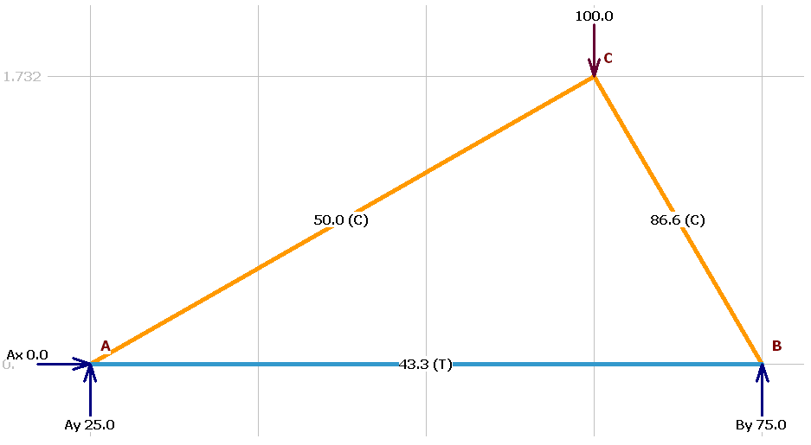

**Member forces for unit horizontal load (2 marks)**

**khAB = 0.25 kN**

**khAC = 0.866 kN**

**khBC = -0.5 kN**

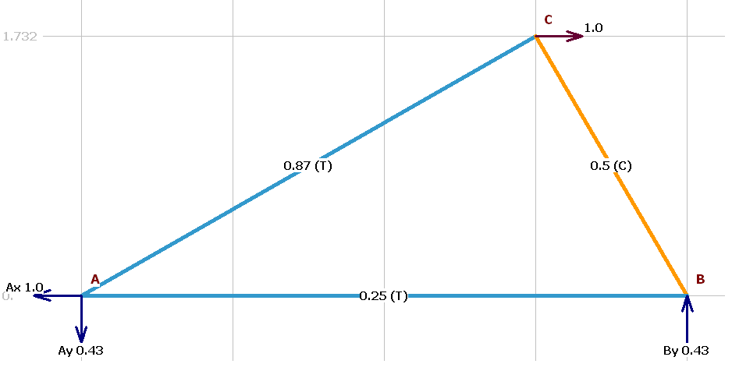

**Calculation** - From the principle of virtual work, the virtual work equation for truss is (2marks)

$1.∆=\sum_{i=1}^{m}{\frac{k_{i}F_{i}L_{i}}{A_{i}E_{i}}}+\sum_{i=1}^{n}{k_{i}L_{i}α_{i} {ΔT}_{i}}$

Where i denotes member number, k is the internal member forces due to virtual load, $\frac{F_{i}L_{i}}{A_{i}E_{i}}$ is the real displacement of ith member due to real load and $L_{i}α_{i} {ΔT}_{i}$ is the real displacement of ith member due to change in temperature.

|  |  |  |  |  |  |  |  |  |  |
| --- | --- | --- | --- | --- | --- | --- | --- | --- | --- |
| Member | (m) | (m2) | (kN/m2) | (kN) | (kN) | (m) | ( / °C) | $${ΔT}_{i }$$ (°C) | $$K_{hi}L_{i }α_{i }{ΔT}_{i }$$ (m) |
| AB | 4 | 3.00E-04 | 2.00E+08 | 0.25 | 43.302 | 7.217E-04 | 1.20E-05 | 10 | 1.200E-04 |
| AC | 3.464 | 4.00E-04 | 2.00E+08 | 0.866 | -50 | -1.875E-03 | 1.20E-05 | 15 | 5.400E-04 |
| BC | 2 | 6.00E-04 | 2.00E+08 | -0.5 | -86.603 | 7.217E-04 | 1.20E-05 | 20 | -2.400E-04 |
|  |  |  |  |  | **TOTAL** | **-4.315E-04** |  |  | **4.200E-04** |

**Final answer (2marks)**

**Horizontal displacement of joint C due to load is -0.4315 mm (ie. .4315mm in the left direction)**

**Additional horizontal displacement due to temperature is 0.42mm**

**Total horizontal displacement of joint C will be -0.0115mm (0.0115 mm in the left direction2**

**Section – D Descriptive Questions with Choice (4x10=40 Marks)**

22.(a). Using the method of virtual work, find the vertical displacement component of point E of the pin-jointed truss shown in fig. 2. Cross sectional areas of members are : AE and FD = 250mm2; EF and EC = 1875mm2; AB, BC, CD, EB and FC = 1250mm2 and E=200kN/mm2. (10)

**Fig. 2**

3m

3m

3m

2m

A

B

C

D

F

E

150 kN

200 kN

**Reactions for real load (1 marks)**

**RA = 183.33kN and RB = 166.67kN**

**Member forces for real load (3 marks)**

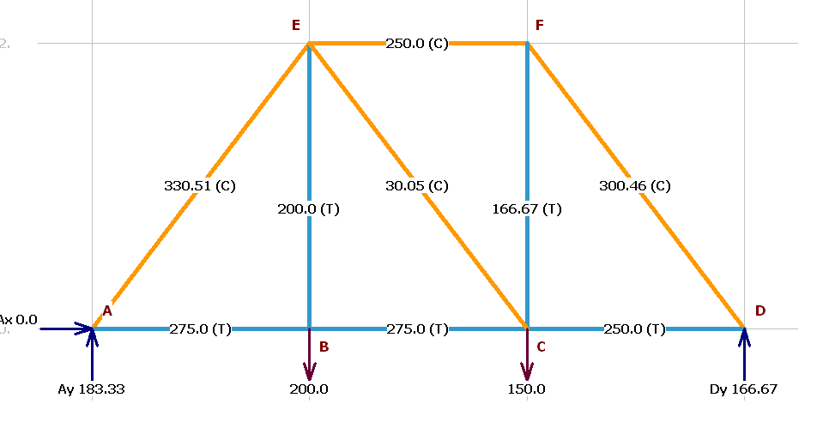

**Member forces for unit virtual load (3 marks)**

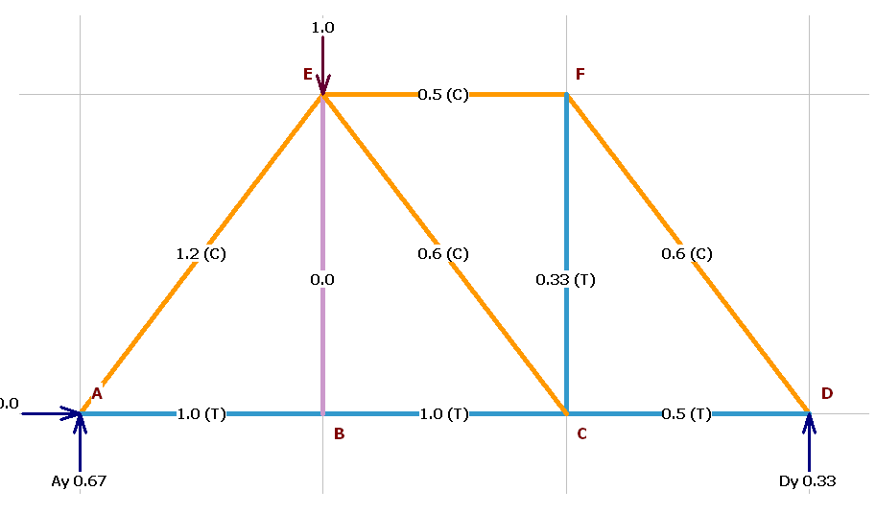

**Calculation and final answer (3 marks)**

|  |  |  |  |  |  |  |
| --- | --- | --- | --- | --- | --- | --- |
| Member | (m) | (m2) | (kN/m2) | (kN) | (kN) | (m) |
| AB | 3 | 1.250E-03 | 2.000E+08 | 275 | 1 | 3.30E-03 |
| AE | 3.606 | 2.500E-04 | 2.000E+08 | -330.51 | -1.2 | 2.86E-02 |
| BE | 2 | 1.250E-03 | 2.000E+08 | 200 | 0 | 0.00E+00 |
| BC | 3 | 1.250E-03 | 2.000E+08 | 275 | 1 | 3.30E-03 |
| CE | 3.606 | 1.875E-03 | 2.000E+08 | -30.05 | -0.6 | 1.73E-04 |
| CF | 2 | 1.250E-03 | 2.000E+08 | 166.67 | 0.33 | 4.40E-04 |
| CD | 3 | 1.250E-03 | 2.000E+08 | 250 | 0.5 | 1.50E-03 |
| DF | 3.606 | 2.500E-04 | 2.000E+08 | -300.46 | -0.6 | 1.30E-02 |
| EF | 3 | 1.875E-03 | 2.000E+08 | -250 | -0.5 | 1.00E-03 |
|  |  |  |  |  | TOTAL | 0.051319 |

Vertical Displacement of E is 0.05132m or 51.32mm

OR

22.(b). Find the vertical displacement of joint ‘J1’ of the plane truss subjected to the load as shown in fig. 3. The figures in the parenthesis show the area of cross section of the members in mm2. Take E=200 GPa. (10)

**Fig. 3**

2m

J2

J4

200kN

J1

J3

J5

(80)

(80)

(40)

(40)

(120)

(120)

2m

2m

**Reactions for real load (1 marks)**

**VA = 200kN↑ , VC = 0kN , HA = 400kN→ and HC = 400kN← .**

**Member forces for real load (3 marks)**

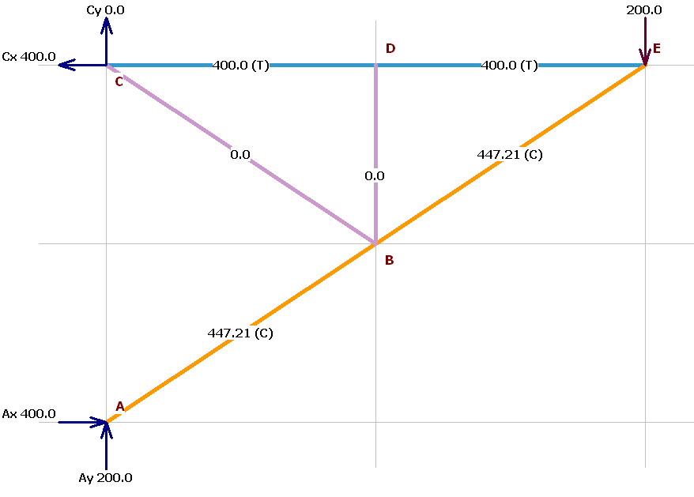

**Member forces for unit virtual load (3 marks)**

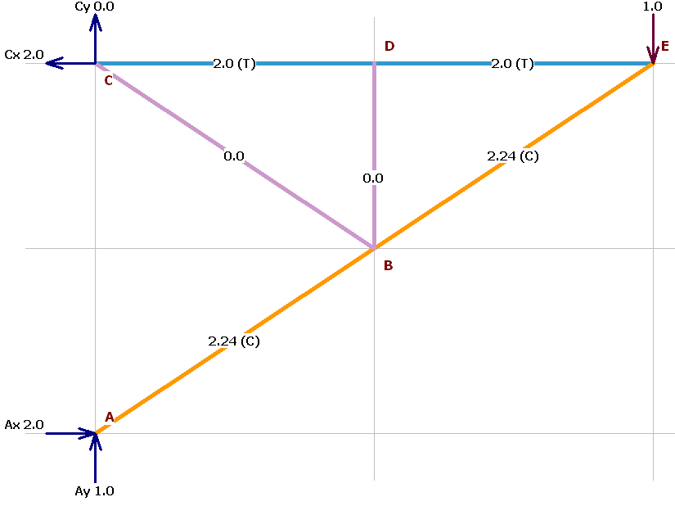

**Calculation and final answer (3 marks)**

|  |  |  |  |  |  |  |
| --- | --- | --- | --- | --- | --- | --- |
| Member | (m) | (m2) | (kN/m2) | (kN) | (kN) | (m) |
| 1 | 2 | 8.00E-05 | 2.00E+08 | 400 | 2 | 1.000E-01 |
| 2 | 2.236 | 1.20E-04 | 2.00E+08 | -447.21 | -2.236 | 9.316E-02 |
| 3 | 1 | 4.00E-05 | 2.00E+08 | 0 | 0 | 0.000E+00 |
| 4 | 2 | 8.00E-05 | 2.00E+08 | 400 | 2 | 1.000E-01 |
| 5 | 2.236 | 4.00E-05 | 2.00E+08 | 0 | 0 | 0.000E+00 |
| 6 | 2.236 | 1.20E-04 | 2.00E+08 | -447.21 | -2.236 | 9.316E-02 |
|  |  |  |  |  | TOTAL | 3.863E-01 |

Vertical Displacement of E is .3863 m or 38.63 cm downward

23.(a). Using principle of virtual work, find the deflection and slope at quarter span of simply supported beam of span of span ‘L’ when loaded with udl of intensity w/unit length throughout the span. (10)

*x1*

*x2*

*x1*

*x2*

L

B

L/4

D

*x1*

*x2*

(+)

(+)

(+)

(-)

BMD due to unit virtual moment at D

RA=1/L kN

RB=-1/L kN

m1θ = *x*1*/L 0 ≤ x*1*≤ 0 .25L*



m2θ = -*x*2*/L* *0 ≤ x*2*≤ 0.75L*

BMD due to given real load

RA=



RB=



M1 = *0 ≤ x*1*≤ 0.25L*



M2 = *0 ≤ x*2*≤*



BMD due to unit virtual load at D

RA=0.75kN

RB=0.25kN

m1 = 0.75 *x*1*0 ≤ x*1*≤ 0 .25L*



m2 = 0.25 *x*2*0 ≤ x*2*≤ 0.75L*

From the principle of virtual work, the virtual work equation is

For this problem

Substituting and integrating:

$$1.∆=\int_{0}^{0.25L}{ \frac{0.75x_{1}\left(\frac{wL}{2} x_{1}-\frac{wx_{1}^{2}}{2} \right){dx}_{1}}{EI}}+ \int_{0}^{0.75L}{ \frac{0.25x_{2}\left(\frac{wL}{2} x_{2}-\frac{wx_{2}^{2}}{2} \right){dx}_{2}}{EI}}$$

$1.∆=\frac{13wL^{4}}{8192EI}+\frac{63wL^{4}}{8192EI}$ = $\frac{19wL^{4}}{2048EI}$

Deflection at the quarter span is

From the principle of virtual work, the virtual work equation is

$$1.θ=\int{\frac{m_{θ}M dx}{EI}}$$

For this problem

$$1.θ\int_{0}^{0.25L}{ \frac{m_{1θ }M_{1}{dx}_{1}}{EI}}+ \int_{0}^{0.75L}{ \frac{m_{2θ}M_{2}{dx}_{2}}{EI}}$$

Substituting and integrating:

$$1.θ\int_{0}^{0.25L}{ \frac{ \frac{x_{1}}{L}\left(\frac{wL}{2} x_{1}-\frac{wx_{1}^{2}}{2} \right){dx}_{1}}{EI}}+ \int_{0}^{0.75L}{ \frac{\left(-\frac{x_{2}}{L} \right)\left(\frac{wL}{2} x_{2}-\frac{wx_{2}^{2}}{2} \right){dx}_{2}}{EI}}$$

$1.θ=\frac{13wL^{3}}{6144EI}-\frac{63wL^{3}}{2048EI}$ = $\frac{-11wL^{3}}{384EI}$

Slope at the quarter span is θ $= -\frac{11wL^{3}}{384EI}$ = -0.0286 $\frac{wL^{3}}{EI}$ radians

(-) means clockwise rotation.

OR

23.(b). Using the method of virtual work, determine the deflection and slope at the free end of the cantilever beam shown in fig. 4. (10)

BMD due to unit virtual load at D

m1 = -*x*1*0 ≤ x*1*≤ L*



m2 = -(L+ *x*2*) 0 ≤ x*2*≤ L*

BMD due to given real load

M1 = *0 ≤ x*1*≤ L*

M2 = *0 ≤ x*2*≤*

BMD due to unit virtual moment at B

m1θ = 1 *0 ≤ x*1*≤L*



m2θ = 1 *0 ≤ x*2*≤ L*

*x1*

*x2*

*x1*

*x1*

(+)

(+)

(+)

(+)

*x2*

*x2*

L

L

2EI

EI

P

B

A

**Fig. 4**

From the principle of virtual work, the virtual work equation is

$$1.∆=\int{\frac{m M dx}{EI}}$$

For this problem

Substituting and integrating:

$$1.∆=\int_{0}^{L}{ \frac{-x_{1}\left(-P x_{1} \right){dx}_{1}}{EI}}+ \int_{0}^{L}{ \frac{-(L+x_{2})\left(-P(L+x_{2}\right)){dx}_{2}}{2EI}}$$

$1.∆=\frac{PL^{3}}{3EI}+\frac{7wL^{3}}{6EI}$ = $\frac{3PL^{3}}{2EI}$

Deflection at the quarter span is

From the principle of virtual work, the virtual work equation is

$$1.θ=\int{\frac{m_{θ}M dx}{EI}}$$

For this problem

$$1.θ\int_{0}^{L}{ \frac{m_{1θ }M_{1}{dx}_{1}}{EI}}+ \int_{0}^{L}{ \frac{m_{2θ}M_{2}{dx}_{2}}{2EI}}$$

Substituting and integrating:

$$1.θ\int_{0}^{L}{ \frac{ 1. \left(-P x_{1} \right){dx}_{1}}{EI}}+ \int_{0}^{L}{ \frac{1. \left(-P(L+x_{2}) \right){dx}_{2}}{2EI}}$$

$1.θ=\frac{-PL^{2}}{2EI}+\frac{-3PL^{2}}{4EI}$ = $\frac{-5PL^{2}}{4EI}$

Slope at the quarter span is θ $= -\frac{5PL^{2}}{4EI}$ = -1.25 $\frac{PL^{2}}{EI}$

(-) means clockwise rotation.

24.(a). Determine the horizontal displacement at support D of the frame shown in fig. 5. Relative I values are indicated along the members. E=200x106 kN/m2 and I = 300x10-6 m4. Use the principle of virtual work. (10)

*x*2

BMD due to unit virtual load at D

HA=1kN ←

VA=0kN



VD=0kN

m1 = *x*1*0 ≤ x*1*≤ 4*

m2 = 4 kNm *0 ≤ x*2*≤ 6*

m3 =1(2+*x*3) *0 ≤ x*3*≤2*

m4 = 1( *x*4) *0 ≤ x*4*≤ 2*

BMD due to given real load

HA=25kN ←

VA=8.333kN↓



VD=8.333kN↑

M1 = 0*0 ≤ x*1*≤ 4*

M2 = 8.333 *x*2 *0 ≤ x*2*≤ 6*

M3 =25(2+*x*3)-25*x*3 =50kNm *0 ≤ x*3*≤ 2*

M4 = 25 *x*4 *0 ≤ x*4*≤ 2*

*x*1

*x*3

*x*4

25kN

2m

2m

6m

2I

I

I

A

B

C

D

**Fig. 5**

From the principle of virtual work, the virtual work equation is

$$1.∆=\int{\frac{m M dx}{EI}}$$

For this problem

$$1.∆=\int_{0}^{4}{ \frac{m_{1}M_{1}{dx}_{1}}{EI}}+ \int_{0}^{6}{ \frac{m_{2}M_{2}{dx}_{2}}{2EI}}+\int_{0}^{2}{ \frac{m_{3}M_{3}{dx}_{3}}{EI}}+ \int_{0}^{2}{ \frac{m_{4}M_{4}{dx}_{4}}{EI}}$$

Substituting and integrating:

$$1.∆=\int_{0}^{4}{ \frac{x_{1}(0){dx}_{1}}{EI}}+ \int_{0}^{6}{ \frac{4(8.333x_{2}{)dx}_{2}}{2EI}}+\int_{0}^{2}{ \frac{\left(2+x_{3}\right)(50){dx}_{3}}{EI}}+ \int_{0}^{2}{ \frac{x_{4}(25x_{4}){dx}_{4}}{EI}}$$

$1.∆=0+ \frac{299.988}{EI}+\frac{300}{EI}+\frac{66.667}{EI}$ = $\frac{666.655}{60000}=0.0111m$

Displacement of joint D is $∆ = 0.0111m or 11.1mm$ towards right.

OR

24.(b). Using the method of virtual work, find the vertical deflection and slope at the free end of the post shown in Fig. 6. E=200kN/mm2, I = 40x106 mm4. (10)

BMD due to given real load

M1 = *0 ≤ x*1*≤ 4*

M2 = *0 ≤ x*2*≤*

*x*2

*x*1

**Fig. 6**

4 m

30kN

6 m

2I

I

BMD due to unit virtual load at free end

m1 = -*x*1*0 ≤ x*1*≤ 4*



m2 = -4  *0 ≤ x*2*≤ 6*

BMD due to unit virtual moment at free end

m1θ = 1 *0 ≤ x*1*≤4*



m2θ = 1 *0 ≤ x*2*≤ 6*

From the principle of virtual work, the virtual work equation is

$$1.∆=\int{\frac{m M dx}{EI}}$$

For this problem

$1.∆=\int_{0}^{L}{ \frac{m_{1}M_{1}{dx}_{1}}{EI}}+ \int_{0}^{L}{ \frac{m_{2}M_{2}{dx}_{2}}{2EI}}$

EI= 200×106 × 40x106 x 10-12=8000

Substituting and integrating:

$$1.∆=\int_{0}^{4}{ \frac{-x_{1}\left(-30x_{1} \right){dx}_{1}}{EI}}+ \int_{0}^{6}{ \frac{-4\left(-120\right){dx}_{2}}{2EI}}$$

$1.∆=\frac{640}{EI}+\frac{1440}{EI}$ = $\frac{2080}{EI}$ = $\frac{2080}{8000}=0.26m=260mm$

Deflection at the free end is $∆ = 260mm$

From the principle of virtual work, the virtual work equation is

$$1.θ=\int{\frac{m_{θ}M dx}{EI}}$$

For this problem

$$1.θ\int_{0}^{L}{ \frac{m_{1θ }M_{1}{dx}_{1}}{EI}}+ \int_{0}^{L}{ \frac{m_{2θ}M_{2}{dx}_{2}}{2EI}}$$

Substituting and integrating:

$$1.θ\int_{0}^{4}{ \frac{ 1. \left(-30x_{1} \right){dx}_{1}}{EI}}+ \int_{0}^{6}{ \frac{1. \left(-120\right){dx}_{2}}{2EI}}$$

$1.θ=\frac{-240}{EI}+\frac{-360}{EI}$ = $\frac{-600}{EI}= = \frac{-600}{8000}= -0.075rad$ ians

Slope at the quarter span is θ $= -0.075 radians$

(-) means clockwise rotation.

25.(a). A train of concentrated loads shown in figure below moves from left to right with a lead load 40kN on a simply supported girder of span 16m.

21kN

60kN

80kN

40kN

3m

2m

2m

16m

B

A

Determine the absolute maximum shear force and absolute maximum bending moment developed in the beam. (10)

For determining absolute max BM

Step 1 Critical load. Left span = 8m and right span 8m

|  |  |  |  |  |
| --- | --- | --- | --- | --- |
| S.No. | Load on left span (kN) | Avg load on left span | Avg load on Right span | Load on right span (kN) |
| 1 | 21+60+80+40 =201 | 25.125 | 0 | 0 = 0 |
| 2 | 21+60+80 =161 | 20.125 | 5 | 40 = 40 |
| 3 | 21+60 = 81 | 10.125 | 20 | 80+40 = 100 |
| 4 | 21 = 21 | 2.625 | 22.5 | 60+80+40 = 180 |
| 5 | 0 = 0 | 0 | 25.125 | 21+60+80+40 =201 |

The 80kN is the critical load

Step 2 – Resultant load and its location

$\overline{x}=\frac{(21×0)\left(60×3\right)+\left(80×5\right)+\left(40×7\right)}{21+60+80+40}=\frac{860}{201}=4.2786m$ from left end of the load system.

**R**

0.7214m

4.2786m

21kN

60kN

80kN

40kN

3m

2m

2m

0.3607m

4.6393m

c = 0.7214m [distance between Resultant and critical load]

Midpoint between resultant and the critical load

Step 3 – Position the load system

21kN

60kN

80kN

40kN

3m

2m

2m

4.2786m

0.7214m

**R**

5.6393m

4.6393m

3.3607m

A

B

0.3607m

8m

16m

midspan

Step 4 – Calculate the BM under the critical load which is at 8.3607m from left end.

ILD for BM under critical load (at 8.3607m from left).

Ordinates under the loads are shown

2.9468

3.9919

3.0370

1.6046

BM under the critical load = (21*1.6046)+(60*3.0370)+(80*3.9919)+(40*2.9468) = 653.14 kNm

Absolute Bending moment is 653.14 kNm

OR

25.(b). A simply supported beam has a span of 15m and is subjected to a 5 m long uniformly distributed load of 40kN/m, traversing along the span from left to right. Draw influence line diagram for shear force and bending moment at a section 6m from left end. Use the influence diagrams to calculate the maximum shear force and maximum bending moment at this section. (10)

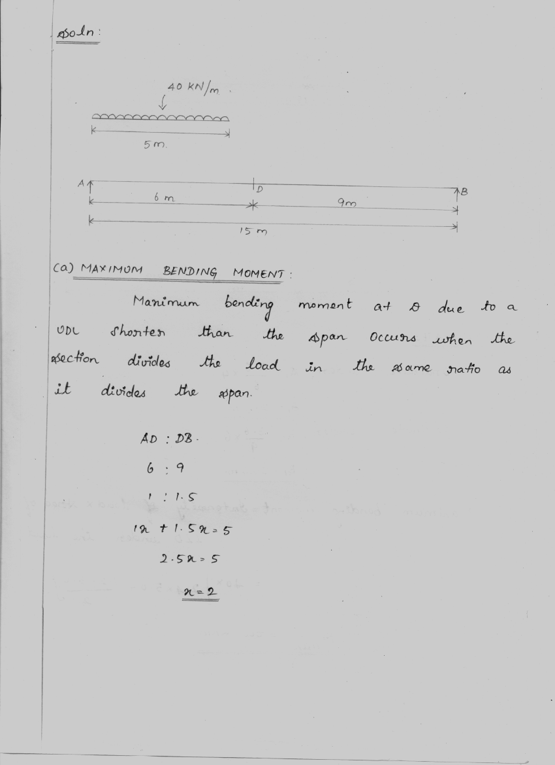

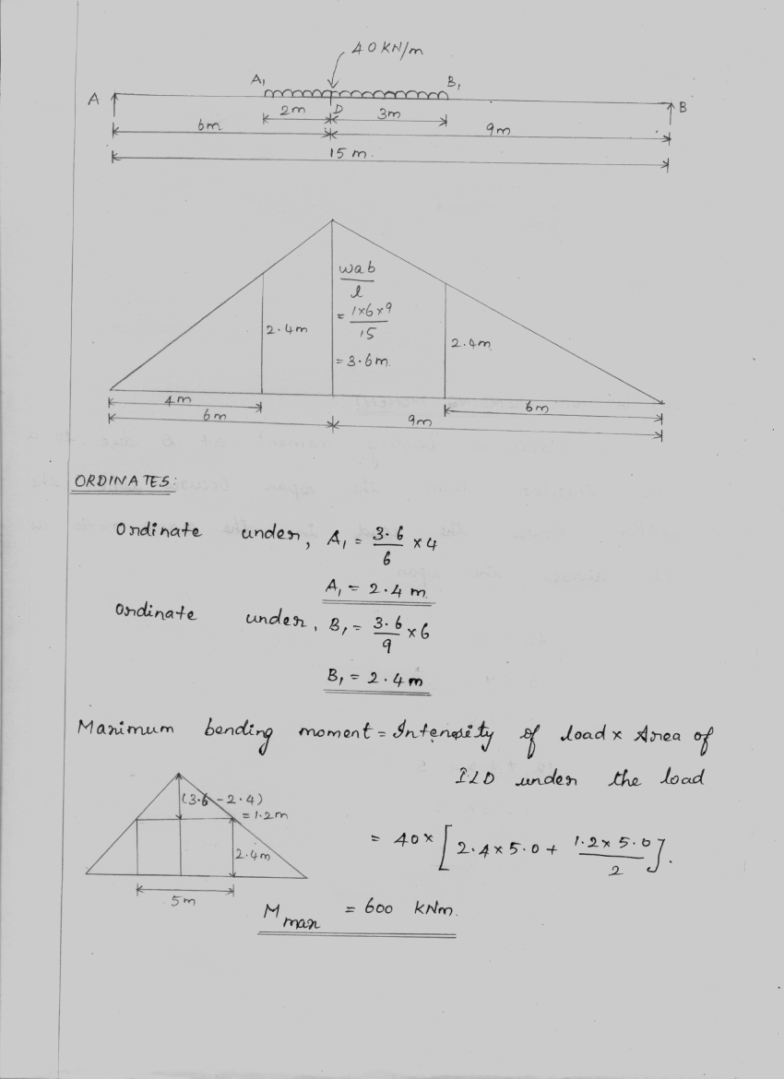

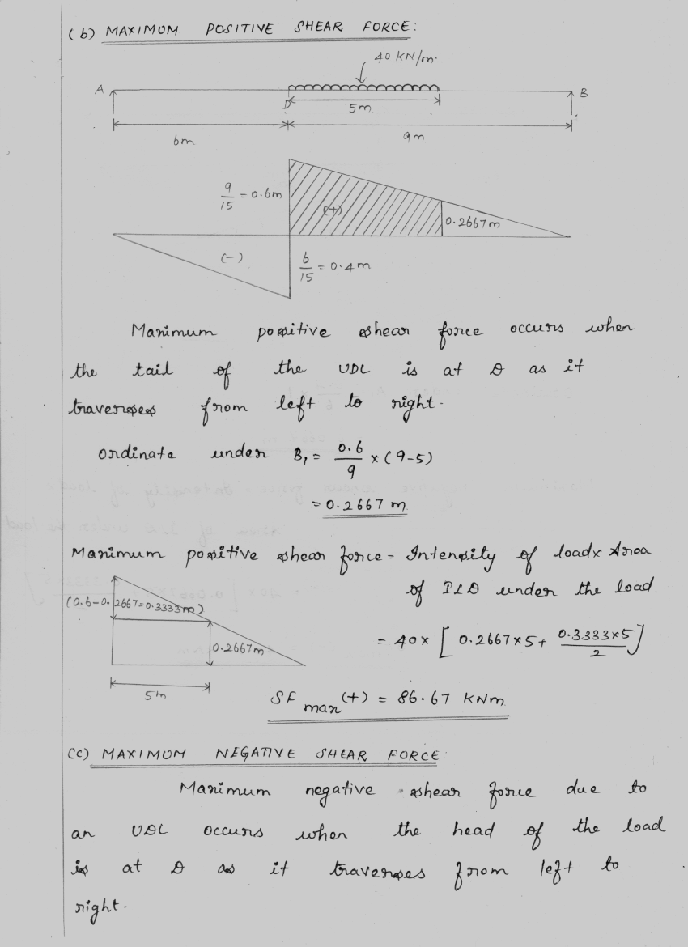

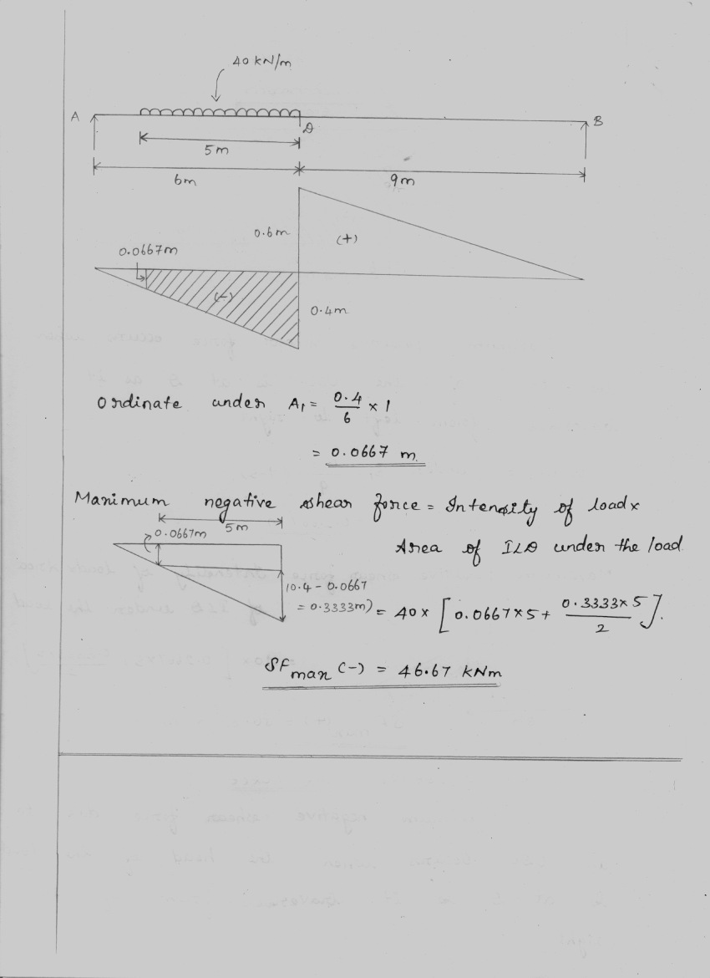

*************** END ****************