**Dr. Mahalingam College of Engineering & Technology**

**Pollachi- 642003**

CONTINUOUS ASSESSMENT TEST – III - KEY

Class & Branch : III B.E. - CIVIL Max. Marks : 50

Sub. Code & Name : STRUCTURAL ANALYSIS - I Time :

Semester : V Date : 29/10/2011

**PART – A (10 x 2 = 20 Marks)**

**Answer all questions :**

1. What is moment distribution method?

The moment distribution method is a structural analysis method for statically indeterminate beams and frames developed by Hardy Cross in 1930. In the moment distribution method, every joint of the structure to be analysed is considered as fixed so as to develop the fixed-end moments due to loads. Then after release the known moments at joints, each fixed joints having more than one member are balanced for unbalanced moment. The balance moments are distributed according to the distribution factors of members and moments are carried over to other end. The iteration is repeated until equilibrium is achieved.

1. What is the difference between absolute and relative stiffness?

Absolute stiffness is represented in terms of E (young’s modulus), I (Moment of Inertia) and L (Length of member) to indicate the moment/force required such as $\frac{4EI}{L}$ to produce unit slope/deflection/deformation. Whereas relative stiffness is represented in terms of I and L, omitting constant E (when structural elements connected to joints are made of same material).

1. Briefly explain stiffness factor and distribution factor.

**Stiffness factor**

Stiffness factor is the moment required to produce an unit rotation at that end without producing translation at the far end.

**Distribution factor**

When several members meet at a joint and a moment is applied at the joint to produce rotation without translation of the members, the moment is distributed among all the members meeting at that joint proportionate to their stiffness.

$$Distribution factor = \frac{stiffness of the member}{Sum of stiffness of members at the joint}$$

1. What is carry over moment and carry over factor?

**Carry over moment**

It is defined as the moment induced at the fixed end of the beam by the action of a moment applied at the other end, which is hinged. Carry over moment is the same nature of the applied moment.

**Carry over factor ( C.O.F)**

A moment applied at the hinged end B “ carries over” to the fixed end A, a moment equal to half the amount of applied moment and of the same rotational sense.

C.O =0.5

1. Explain term balancing in the moment distribution method.

Algebraic sum of clockwise and counter-clockwise moments at any internal joint should be zero for equilibrium. When this sum is not zero, equivalent and opposite moment is applied at that joint to achieve the equilibrium. This step is called balancing.

1. Three members meeting at a rigid joint carry moments 5 kNm(clockwise), 10kNm (clockwise) and 9kNm (counter-clockwise). What moment should be applied to balance?

6kNm (Counter-clockwise)

1. Distribute an applied balancing moment of 12kNm at a joint among three members whose relative stiffnesses are 1/6, 1/3 and 1/2.

2kNm, 4kNm and 6kNm respectively for the members having relative stiffnesses of 1/6, 1/3 and 1/2.

1. An udl of 50kNm acting on one the span of two span continuous beam which is symmetrical and each span length is l. Sketch the equivalent load interms of symmetric and anti-symmetric loads.

l

A

B

l

C

25 kN/m

25 kN/m

25 kN/m

l

A

B

l

C

25 kN/m

Symmetrical loads Anti-symmetrical loads

1. Sketch the reduced structure with support condition for the two span symmetric portal whose columns are fixed at the ground.

A

B

C

A

B

C

For symmetrical loading

For Anti-symmetrical loading

1. What is Naylor’s method?

In the naylors method (also called cantilever moment distribution method), for symmetrical frames, columns are assumed as one end is free to rotate and translate and other end as fixed (similar to cantilever). The end moments are calculated based on this assumption and then the balancing and carry over is iteratively done by suitably modifying the member stiffness. In this method, sway analysis is completely avoided.

**PART – B ( 3 x 10 = 30 Marks)**

**Answer any three of the following**

1. Analyse the portal frame shown in fig. 1 using slope deflection method and sketch the bending moment and shear force diagram. (10)

Solution Outline

A

B

2m

C

D

Fig. 1

48 kN

2m

4m

(2Io )

( Io )

(Io)

6m

10 kN/m

6 kN/m

1. Find fixed end moments due to loads
2. Write slope-deflection equations
3. Obtain joint equilibrium equations
4. Obtain shear equation.
5. Solve joint equilibrium equations and shear

equation to get the slopes and deflections

1. Find final end moments by substituting slopes

and deflections in slope-deflection equations.

1. Draw the bending moment diagram
2. Draw the shear force diagram

DETAIL SOLUTION

Step 1: Find fixed end moments due to loads

$M_{FAB}= -\frac{wl^{2}}{12}=-\frac{6{×4}^{2}}{12}=-8 kNm$; $M_{FBA}= +\frac{wl^{2}}{12}=+\frac{6{×4}^{2}}{12}=+8 kNm$

$M_{FBC}= -\frac{Wl}{8}=-\frac{48×4}{8}=-24 kNm$; $M_{FCB}= +\frac{Wl}{8}=+24kNm$

$M_{FCD}= -\frac{wl^{2}}{12}=-\frac{10{×6}^{2}}{12}=-30kNm$; $M_{FDC}=\frac{wl^{2}}{12}=\frac{10{×6}^{2}}{12}=30kNm$

 Step 2: Slope-deflection equations

$$M_{AB}=M_{FAB}+\frac{4EI_{o}θ_{A}}{l}+\frac{2EI_{o}θ_{B}}{l}-\frac{6EI_{o}δ}{l^{2}}=-8+\frac{EI_{o}θ_{B}}{2}-\frac{3EI_{o}δ}{8}$$

$$M_{BA}=M_{FBA}+\frac{2EI_{o}θ_{A}}{l}+\frac{4EI_{o}θ_{B}}{l}-\frac{6EI_{o}δ}{l^{2}}= 8+EI_{o}θ_{B}-\frac{3EI_{o}δ}{8}$$

$$M_{BC}=M_{FBC}+\frac{4EI_{o}θ_{B}}{l}+\frac{2EI_{o}θ_{C}}{l}= -24+EI_{o}θ_{B}+\frac{EI_{o}θ_{C}}{2}$$

$$M_{CB}=M_{FCB}+\frac{2EI_{o}θ_{B}}{l}+\frac{4EI_{o}θ_{C}}{l}= 24+\frac{EI_{o}θ_{B}}{2}+EI_{o}θ_{C}$$

$$M_{CD}=M_{FCD}+\frac{4E(2I_{o})θ_{C}}{l}+\frac{2E{(2I}_{o})θ_{D}}{l}-\frac{6E{(2I}_{o})δ}{l^{2}}=-30+\frac{4EI_{o}θ_{C}}{3}-\frac{EI_{o}δ}{3}$$

$$M_{DC}=M_{FDC}+\frac{2E(2I_{o})θ_{C}}{l}+\frac{4E{(2I}_{o})θ_{D}}{l}-\frac{6E{(2I}_{o})δ}{l^{2}}=30+\frac{2EI_{o}θ_{C}}{3}-\frac{EI_{o}δ}{3}$$

Step 3: joint equilibrium equations

Joint B

🡪 = 0

Joint C

🡪 = 0

Step 4: Shear equation

$$H_{A}+H_{D}+24-60=0$$

$H_{A}=\frac{M_{AB}+M_{BA}}{4}-\frac{24×2}{4}$ and $H_{D}=\frac{M_{CD}+M_{DC}}{6}+\frac{60×3}{6}$

Substituting $H_{A} and H_{D}$ and Substituting moments interms of slope and deflection, the shear equation is obtained as follows:

$$\frac{3EI_{o}θ_{B}}{8}+\frac{EI_{o}θ_{C}}{3}-\frac{43EI_{o}δ}{144}-18=0$$

Step 5: Solve joint equilibrium equations along with shear equation to get the slopes and deflections

$EI_{o}θ_{B}= -\frac{1523}{386}$, $EI_{o}θ_{C}= -\frac{5421}{772} and EI_{o}δ= -\frac{14103}{193}$ are obtained by solving joint equilibrium equations and shear equation.

Step 6: Final Fixd end moments

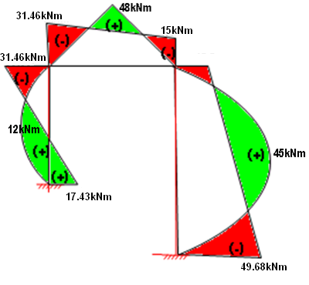Substituting $EI_{o}θ_{B}= -3.946$, $EI_{o}θ_{C}= -7.022 and EI_{o}δ= -73.073$ in slope-deflection equations, we get,

$M_{AB}=17.43kNm$; $M_{BA}=31.46kNm$

$M_{BC}=-31.46kNm$; $M_{CB}=+15.0kNm$

$M_{CD}=-15.0kNm$; $M_{DC}=+49.68kNm$

Step 7: Draw the bending moment diagram

Step 8: Draw the shear force diagram

$H_{A}=\frac{17.43+31.46}{4}-\frac{24×2}{4}$ = 0.22kN

$$H_{D}=\frac{-15.0+49.68}{6}+\frac{60×3}{6}=35.78kN$$

Find RA and RD, then draw shear force diagram

1. Analyse the structure loaded as in fig. 2. by the moment distribution method and sketch the bending moment and shear force diagram (10)

Solution Outline

3m

A

B

C

D

20kN/m

4m

(2I)

(I)

(2I)

80 kN

2m

Fig. 2

2m

1. Find fixed end moments due to loads
2. Determine distribution factors for members

at each internal joint

1. Tabulate initial fixed end moments, release

or apply known moments

1. Balance the unbalanced moment and carry over

the moments.

1. If the carry over moments unbalances the

joint equilibrium, do step 4 and 5 repeatedly

till unbalanced moment is negligible.

1. Find out the final end moment by summing all the initial, balanced moments and carry over moments for each end of the span.
2. Draw the bending moment diagram
3. Draw the shear force diagram

DETAIL SOLUTION

Step 1: Find fixed end moments due to loads

$M_{FAB}= -\frac{wab^{2}}{l^{2}}=-\frac{80{×3×2}^{2}}{5^{2}}=-38.4kNm$; $M_{FBA}= \frac{wa^{2}b}{l^{2}}=\frac{80×3^{2}×2}{5^{2}}=57.6kNm$

$M_{FBC}= -\frac{wl^{2}}{12}=-\frac{20{×2}^{2}}{12}=-6.67kNm$; $M_{FCB}= \frac{wl^{2}}{12}=\frac{20{×2}^{2}}{12}=6.67kNm$

$M_{FBD}= 0kNm$; $M_{FDB}=0kNm$

Step 2: Determine distribution factors for members at each internal joint

|  |  |  |  |  |
| --- | --- | --- | --- | --- |
| Joint | Member | Stiffness | Total Stiffness | Distribution Factor |
| B | BA | $$\frac{3EI}{l}=\frac{3E 2I}{5}=1.2EI$$ | $$5.2EI$$ | 0.2308 |
| BC | $$\frac{4EI}{l}=\frac{4E I}{2}=2EI$$ | 0.3846 |
| BD | $$\frac{4EI}{l}=\frac{4E 2I}{4}=2EI$$ | 0.3846 |

Steps 3 to 6

|  |  |  |  |  |  |  |
| --- | --- | --- | --- | --- | --- | --- |
| Joint | A | B | | | C | D |
| Member | AB BA | | BD | BC CB | | DB |
| C.O.F | 0 0.5 | | 0.5 | 0.5 0.5 | | 0.5 |
| D.F | 1 0.2308 | | 0.3846 | 0.3846 1 | | 1 |
| FEM | -38.4 57.6 | | 0 | -6.7 6.7 | | 0 |
| Release | +38.4 | |  |  | |  |
| C/O | 19.2 | |  |  | |  |
| **Initial Moment** | **0 76.8** | | **0** | **-6.7 6.7** | | **0** |
| Balance 1 | -16.2 | | -27 | -27 | |  |
| C/O 1 |  | |  | -13.5 | | -13.5 |
| **Final End moment** | **0 60.6** | | **-27** | **-33.7 -6.8** | | **-13.5** |

Step 7: Draw the bending moment diagram

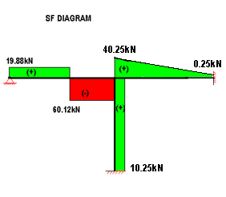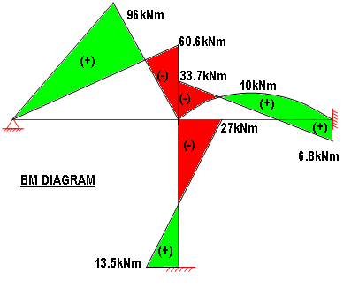

Step 8: Draw the shear force diagram

Find $R_{A}, R_{B}, R_{C} and H_{D}$

Taking moment about B, considering left side.

🡪

Taking moment about B, considering right side.

🡪

From $\sum{V}=0$

$$R_{B}=120-19.88+0.25=100.37kN$$

Taking moment about B, considering forces and moments below.

🡪 (ie) 10.25kN(🡨)

1. Analyse the structure loaded as in fig. 3. by the moment distribution method and sketch the bending moment and shear force diagram (10)

Fig. 3

C

D

( I)

3m

F

E

(2I)

4m

50 kN/m

3m

(I)

A

B

50 kN/m

(2I)

3m

4m

(I)

Solution Outline

1. Considering symmetric structure, analyzing half of the structure is enough to find all the necessary design parameters (BM and SF). So, Consider half of the structure with fixed end at C, since there is support at C (Modification of stiffness is not necessary).
2. Find fixed end moments due to loads
3. Determine distribution factors for members at each internal joint
4. Tabulate initial fixed end moments
5. Balance the unbalanced moment and carry over the moments.
6. If the carry over moments unbalances the joint equilibrium, do step 4 and 5 repeatedly till unbalanced moment is negligible.
7. Find out the final end moment by summing all the initial, balanced moments and carry over moments for each end of the span.
8. Draw the bending moment diagram

A

B

50 kN/m

(2I)

3m

4m

(I)

C

1. Draw the shear force diagram

STEP 1

DETAIL SOLUTION

Step 1: Consider half of the structure with fixed end at C

Step 2: Find fixed end moments due to loads

$M_{FAB}= 0kNm$;

$M_{FBA}= 0kNm$

$M_{FBC}= -\frac{wl^{2}}{12}=-\frac{50{×3}^{2}}{12}=-37.5kNm$;

$M_{FCB}= \frac{wl^{2}}{12}=\frac{50{×3}^{2}}{12}=37.5kNm$

Step 3: Determine distribution factors for members at each internal joint

|  |  |  |  |  |
| --- | --- | --- | --- | --- |
| Joint | Member | Stiffness | Total Stiffness | Distribution Factor |
| B | BA | $$\frac{4EI}{l}=\frac{4E 2I}{4}=2EI$$ | 3.333 $EI$ | 0.6 |
| BC | $$\frac{4EI}{l}=\frac{4E I}{3}=1.333EI$$ | 0.4 |

Steps 4 to 7

|  |  |  |  |  |  |  |  |  |
| --- | --- | --- | --- | --- | --- | --- | --- | --- |
| Joint | A | B | | C | C | E | | F |
| Member | AB BA | | BC CB | | CE EC | | EF CB | |
| C.O.F | 0.5 0.5 | | 0.5 0.5 | |  | |  | |
| D.F | 1 0.6 | | 0.4 1 | |  | |  | |
| Initial FEM | 0 0 | | -37.5 37.5 | |  | |  | |
| Balance 1 | 22.5 | | 15 | |  | |  | |
| C/O 1 | 11.25 | | 7.5 | |  | |  | |
| **Final End moment** | **11.25 22.5** | | **-22.5 45** | | **-45 22.5** | | **-22.5 -11.25** | |

Step 8: Draw the bending moment diagram

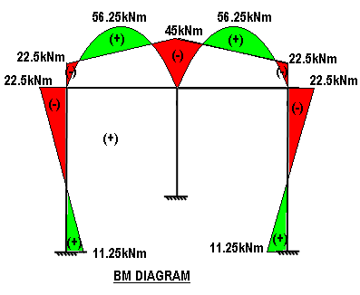

Step 9: Draw the Shear Force diagram

Find $R_{A}, R_{C} and H_{A}$

Taking moment about C, considering left side forces and moments.

🡪 . Because of symmetry, $R_{E}=67.5kN$

From $\sum{V}=0$

$$R_{C}=300-67.5-67.5=165kN$$

Taking moment about B, considering forces and moments below.

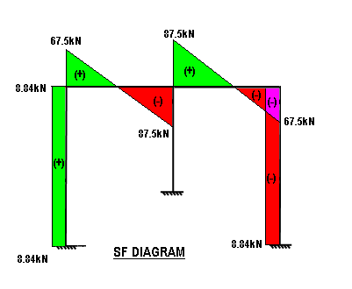

🡪 (ie) 8.84kN(🡨)

1. Analyse the portal frame shown in fig. 4 using Naylor’s method and sketch the bending moment and shear force diagram. (10)

By modifying the stiffness of member in the symmetric line,

Fig. 4

A

B

C

D

50 kN/m

(2I)

3m

4m

(I)

(2I)

4m

100 kN

2m

number of iterations can be reduced. Hence, advantage of the

symmetrical structure is also used in the solution.

Solution Outline

1. Equivalent loads in terms of symmetric and

anti-symmetric loading

1. Analysis for symmetric loading (Moment Distribution method)
2. Find stiffnesses (for fixed end $\frac{4EI}{l}$, for hinged $\frac{3EI}{l}$) and

modify the stiffness of member which is at symmetric

line if no support (multiply with 0.5 for symmetrical loads)

1. Determine distribution factors for members and
2. carry over factors (0.5 for fixed end, 0 for hinged)
3. Find fixed end moments due to symmetrical loads
4. Tabulate initial fixed end moments
5. Balance the moment and carry over the moments.
6. If the carry over moments unbalances significantly the

joint equilibrium, repeat balancing process.

1. Find out the total end moments for symmetrical loads by

summing all the initial, balanced moments and carry

over moments for each end of the span.

1. For other half of the structure, take the opposite moment at the corresponding ends.
2. Naylor method for anti-symmetric loading
3. Find stiffnesses (treat vertical members as cantilever – Stiffness for the cantilever is , for fixed end , for hinged and modify the stiffness of member which is at symmetric line if not support (multiply with 1.5 for anti-symmetrical loads)
4. Determine distribution factors for members
5. carry over factors (0.5 for fixed end, 0 for hinged and -1 for cantilever)
6. Find fixed end moments due to anti-symmetrical loads
7. Tabulate initial fixed end moments
8. Balance the moment and carry over the moments.
9. If the carry over moments unbalances significantly the joint equilibrium, repeat balancing process.
10. Find out the total end moments for anti-symmetrical loads
11. For other half of the structure, take the same moment at the corresponding ends.
12. Obtain final end moment by adding moments from step 2 and step 3
13. Draw the bending moment diagram
14. Draw the shear force diagram

Step 1 : Equivalent symmetric and anti-symmetric loading for a given load

50 kN

50 kN

50 kN

(I)

50 kN/m

C

B

C

B

50 kN

(I)

2m

3m

3m

4m

(2I)

4m

(2I)

4m

(2I)

(2I)

4m

D

D

A

A

Anti-Symmetrical Loading

Symmetrical Loading

Step 2 : Analysis for symmetric loading (Moment Distribution method)

1. Find stiffnesses (for fixed end $\frac{4EI}{l}$, for hinged $\frac{3EI}{l}$) and modify the stiffness of member which is at symmetric line if no support (multiply with 0.5 for symmetrical loads)
2. Determine distribution factors for members

|  |  |  |  |  |
| --- | --- | --- | --- | --- |
| Joint | Member | Stiffness | Total Stiffness | Distribution Factor |
| B | BA | $$\frac{4EI}{l}=\frac{4E 2I}{4}=2EI$$ | 2.667 $EI$ | 0.75 |
| BC  (Unmodified) | $$\frac{4EI}{l}=\frac{4E I}{3}$$ |  |
| BC*  (Modified) | $$\frac{4E I}{3}*0.5=0.667EI$$ | 0.25 |

1. carry over factors (0.5 for fixed end, 0 for hinged)
2. Find fixed end moments due to symmetrical loads

$M_{FAB}= 0kNm$; $M_{FBA}= 0kNm$

$M_{FBC}= -\frac{wl^{2}}{12}-\frac{W_{1}a_{1}b_{1}^{2}}{l^{2}}-\frac{W_{2}a_{2}b_{2}^{2}}{l^{2}}=-\frac{50{×3}^{2}}{12}-\frac{50{×1×2}^{2}}{3^{2}}-\frac{50{×2×1}^{2}}{3^{2}}=-70.83kNm$

(Moment for one-half the structure is enough when advantage of symmetric structure is considered)

Steps 2e to 2i

|  |  |  |  |  |  |  |
| --- | --- | --- | --- | --- | --- | --- |
| Joint | A | B | | C | | D |
| Member | AB BA | | BC | CB CB | CD D | |
| C.O.F | 0.5 0.5 | | 0.5 |  |  | |
| D.F | 1 0.75 | | 0.25 |  |  | |
| Initial FEM | 0 0 | | -70.83 |  |  | |
| Balance 1 | 53.12 | | 17.71 |  |  | |
| C/O 1 | 26.56 | |  |  |  | |
| **Total End moment** | **26.56 53.12** | | **-53.12** | **53.12 22.5** | **-53.12 -26.56** | |

Step 3 : Naylor method for anti-symmetric loading

1. Find stiffnesses (treat vertical members as cantilever – Stiffness for the cantilever is , for fixed end , for hinged and modify the stiffness of member which is at symmetric line if not support (multiply with 1.5 for anti-symmetrical loads)
2. Determine distribution factors for members

|  |  |  |  |  |
| --- | --- | --- | --- | --- |
| Joint | Member | Stiffness | Total Stiffness | Distribution Factor |
| B | BA | $$\frac{EI}{l}=\frac{E 2I}{4}=0.5EI$$ | 2.5 $EI$ | 0.2 |
| BC  (Unmodified) | $$\frac{4EI}{l}=\frac{4E I}{3}$$ |  |
| BC*  (Modified) | $$\frac{4E I}{3}*1.5=2.0EI$$ | 0.8 |

1. carry over factors (0.5 for fixed end, 0 for hinged)
2. Find fixed end moments due to symmetrical loads

$M_{FAB}= 0kNm$; $M_{FBA}= 0kNm$

$M_{FBC}= -\frac{W_{1}a_{1}b_{1}^{2}}{l^{2}}+\frac{W_{2}a_{2}b_{2}^{2}}{l^{2}}=-\frac{50{×1×2}^{2}}{3^{2}}+\frac{50{×2×1}^{2}}{3^{2}}=-11.11kNm$

(Moment for one-half the structure is enough when advantage of symmetric structure is considered)

Steps 3e to 3i

|  |  |  |  |  |  |  |
| --- | --- | --- | --- | --- | --- | --- |
| Joint | A | B | | C | | D |
| Member | AB BA | | BC | CB CB | CD D | |
| C.O.F | -1 -1 | | 0.5 |  |  | |
| D.F | 1 0.2 | | 0.8 |  |  | |
| Initial FEM | 0 0 | | -11.11 |  |  | |
| Balance 1 | 2.22 | | 8.89 |  |  | |
| C/O 1 | -2.22 | |  |  |  | |
| **Total End moment** | **-2.22 2.22** | | **-2.22** | **-2.22 22.5** | **2.22 -2.22** | |

Step 4: Obtain final end moment by adding moments from step 2 and step 3

|  |  |  |  |  |  |  |
| --- | --- | --- | --- | --- | --- | --- |
| Joint | A | B | | C | | D |
| Member | AB BA | | BC | CB CB | CD D | |
| Moment for symmetrical load | **26.56 53.12** | | **-53.12** | **53.12 22.5** | **-53.12 -26.56** | |
| Moment for Anti-symmetrical load | **-2.22 2.22** | | **-2.22** | **-2.22 22.5** | **2.22 -2.22** | |
| Final End moment for a given load | **24.34 55.34** | | **-55.34** | **50.90 22.5** | **-50.90 -28.78** | |

Step 5: Draw the bending moment diagram

No loads at Vertical members. 2 loads are acting at beam, hence, sagging moments due to load at salient points in the beam are as shown below:

Considering simply supported beam, reaction at left support is 75+66.67=141.67kN

$${BM}_{xfrom left}=141.67x-\frac{50{×x}^{2}}{2} for x<1$$

$${BM}_{xfrom left}=141.67x-\frac{50{×x}^{2}}{2}-100×\left(x-1\right)for 1≤x≤3$$

Mathematica – Code snippet to plot piecewise function

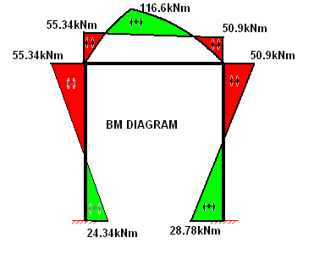



Step 6: Draw the Shear Force diagram

Find $R_{A}=141.67 R_{D}=108.33$

$H_{A}=\frac{23.34+55.34}{4}$ = 19.67kN (ie) 19.67kN(🡪)

(ie) 19.67kN(🡨)

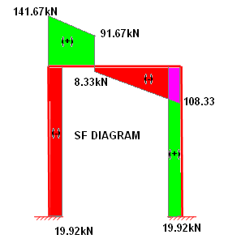

---- End ----