Dr. Mahalingam College of Engineering & Technology
Pollachi- 642003

CONTINUOUS ASSESSMENT TEST – II

Class & Branch : III B.E. - CIVIL Max. Marks : 50
Sub. Code & Name : STRENGTH OF MATERIALS Time : 1½ hrs
Semester : V Date : 05-OCT-2009

PART – A (10 x 2 = 20 Marks)
Answer all questions:

- Differentiate the statically determinate structures and statically indeterminate structures?
- What is the principle of superposition and how do you apply it to solve the propped cantilever beam?
- What are the sagging and hogging moments.
- What is a fixed beam?
- What are the advantages and disadvantages of fixed beam?
- Find the area of BMD for the central load as shown in fig. given below:
4m
50kN

- Find the area of BMD for the non-central load as shown in fig. given below:
60kN
3m
4m

- Compare the deflections in simply supported and fixed beams when subjected the same UDL while span, materials are same.
- Give the deflection under the load in a fixed beam due to non-central point load.
- What is point of contra-flexure?

(P.T.O)
PART – B ( 3 x 10 = 30 Marks)
Answer any three of the following

- Derive the expressions for the unknowns M_{A}, R_{A}, R_{B} for the uniformly varying load ‘w’ at fixed end and zero at propped end as shown fig. 1.
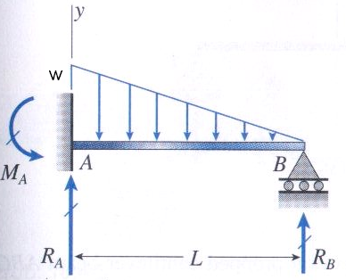Figure. 1
- Draw the Shear force and Bending moment diagrams for the propped cantilever beam as shown in fig. 2.
4m
10kN/m
1m
A
B
C

Figure 2.
- Derive the expressions for M_{A}, M_{B}, R_{A}, R_{B}, the deflection curve and deflection under the load of the fixed beam due to non-central point load.
- A fixed beam of span 8m is subjected to a uniformly varying load of 8kN/m at one support to 6kN/m at the other support. Find the support reactions and moments. Draw S.F. and B.M. diagrams.
- A continuous beam ABC is supported at A, B, and C such that AB=6m and BC =4m. AB carries a point load of 80kN at centre and BC carries a UDL of 30kN/m calculate support moment and draw S.F and BM diagram.

