Dr. Mahalingam College of Engineering & Technology
Pollachi- 642003

Assignment – III – Questions And Answers

Class & Branch : II B.E. - CIVIL Max. Marks : 50
Sub Name : APPLIED HYDRAULIC ENGINEERING Time : 1½ hrs
Semester : IV Assigned Date : 22-APR-2009
Due Date : 22-APR-2009

Answers released date : 23-APR-2009
PART – A (10 x 2 = 20 Marks)
Answer all questions :

- What are the methods used to find the GVF profiles?
Methods for finding GVF profiles
Direct integration methods

Numerical methods

Graphical methods

Simple Numerical Methods

Advanced Numerical Methods

Direct-step method

Standard-step method

Standard Fourth Order Runge-kutta Method (SRK)

kutta-Merson Method (KM)

Trapezoidal Method (TRAP)

- Sketch the GVF profile of the flow in the steep-mild-sluice gate-mild-sudden drop serial arrangement.
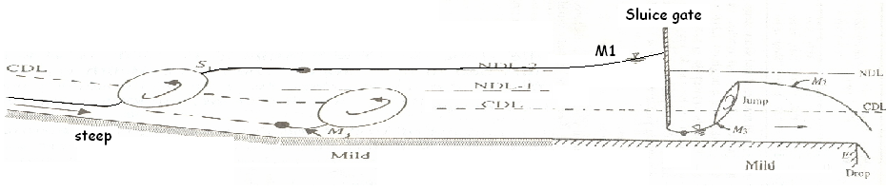

- Write the SRK formula for finding the depth of flow at downstream station 2 when flow properties are known at upstream station 1?
$$y_{2}=y_{1}+\frac{1}{6}\left(K_{1}+2K_{2}+2K_{3}+K_{4}\right)$$
where
$K_{1}=Δ\text{xF}\left(y_{1}\right)$ ; $K_{2}=ΔxF\left(y_{1}+\frac{K_{1}}{2}\right)$ ; $K_{3}=ΔxF\left(y_{1}+\frac{K_{2}}{2}\right)$ ; $K_{4}=ΔxF\left(y_{1}+K_{3}\right)$
and
$F(y)=\frac{\text{dy}}{\text{dx}}=\frac{S_{0}−S_{f}}{1−\left(Q^{2}T/{\text{gA}}^{3}\right)}$ in which T , A and S_{f} are Top width of the flow, Area of flow, Energy slope at depth y which is passed through the function F(y).
$$Δx=x2−x1$$
- Why direct integration method is not used to compute GVF profiles in natural channels?
Using the direct integration method, solution can be obtained only for the simple geometry channels. A closed-form solution of this equation is not available for complex geometric like natural channels because dy/dx becomes a non-linear function.
- What are the sequent depths?
In hydraulic jump, the initial depth of the supercritical stream just before the jump is denoted as y₁ and the final depth of the subcritical stream after the jump is denoted as y₂. These two depths are called as sequent depths.
- Write down the expression for energy loss in rectangular channels due to hydraulic jump in terms of sequent depths?
$E_{L}=\frac{{\left(y_{2}−y_{1}\right)}^{3}}{4y_{1}y_{2}}$ where y1 and y2 are the sequent depths at upstream and downstream respectively.

- Classify the hydraulic jumps based on the Froude number and its gross physical characteristics.
(1) Undular Jump: 1.0< Fr < 1.7
(2) Weak jump: 1.7< Fr < 2.5
(3) Oscillating Jump: 2.5< Fr < 4.5
(4) Steady Jump: 4.5< Fr < 9.0
(5) Strong or Choppy Jump: Fr > 9.0
- What are the practical applications of hydraulic jump?
A hydraulic jump primarily serves as an energy dissipator to dissipate the excess energy of flowing water downstream of hydraulic structures, such as spillways and sluice gates. Some of the other uses are: (a) efficient operation of flow-measurement flumes,(b) mixing of chemicals, (c) to aid intense mixing and gas transfer in chemical processes, (d) in the desalination of sea water and (e) in the aeration of streams which arc polluted by bio-degradable wastes.
- What category of the hydraulic jump is recommended while designing a stilling basin at the downstream portion of the hydraulic structure? Why?
Steady Jump. Steady jump occurs in the range of Froude number 4.5 to 9.0 and the roller and jump action is fully developed to cause appreciable energy loss of 45% to 70%. Moreover, the steady jump is least sensitive in terms of the toe-position to small fluctuations in the tail water elevation.
- What is tail water depth? How do you classify the hydraulic jumps based on tail water depth?
The depth at the downstream of a hydraulic structure, such as a sluice gate, controlled by the downstream channel or local control is known as tailwater depth y_{t}.
The hydraulic jumps based on tail water depth (y_{t}) compared to the sequent depth (y₂) are classified as:
- Free jump if $y_{2}=y_{t}$
- Repelled free jump if $y_{2}>y_{t}$
- Submerged or drowned jump if $y_{2}<y_{t}$
$\frac{y_{t}−y_{2}}{y_{2}}$ is called submergence factor. If this submergence factor is more than 1, jump will submerged in the tail water. The energy dissipation in a submerged jump is smaller than that in a corresponding free jump.
PART – B ( 3 x 10 = 30 Marks)
Answer all the questions
- A rectangular channel having B = 6.0 m, bed slope = 0.0016 and n = 0.020 carries a discharge of 12.0 m3/s. Backwater depth of 4.0 m is produced immediately behind the sluice gate while it was lowered. a) Compute the horizontal distance from the sluice gate at which flow depth is 3.5 m using the direct step method in single step. b) Verify your answer with SRK method and Standard step method. (10)
Direct Step Method:
Formula to be used: $x2=x1+\frac{E_{2}−E_{1}}{\text{So}−\frac{1}{2}(S_{f1}+S_{f2})}$
Given Data:
4.0m
3.5m
x₁
∆x
B=6.0, So=0.0016, n=0.02
Q = 12 m³/s, y₁=4.0, y₂=3.5
x₁=0
Calculations
A₁=B*y₁ =6*4=24 m²
A₂=B*y₂ =6*3.5=21 m²
P₁=B+2y₁ = 6+2*4=14 m²
P₂=B+2y₂ = 6+2*3.5=13 m²
R₁=A₁/P₁ = 24/14=1.7143 m
R₂=A₂/P₂ = 21/13=1.6154 m
V₁=Q/A₁ = 12/24=0.5 m/s
V₂=Q/A₂ = 12/21=0.5714 m/s
$$E_{1}=y_{1}+\frac{V_{1}^{2}}{2g}=4+\frac{0\text{.}5^{2}}{2×9\text{.}\text{81}}=4\text{.}\text{0127 m}$$
$$E_{2}=y_{2}+\frac{V_{2}^{2}}{2g}=3\text{.}5+\frac{0\text{.}{\text{5714}}^{2}}{2×9\text{.}\text{81}}=3\text{.}\text{5166 m}$$
$${\text{Sf}}_{1}=\frac{Q^{2}n^{2}}{A_{1}^{2}R_{1}^{4/3}}=\frac{{\text{12}}^{2}×0\text{.}{\text{02}}^{2}}{{\text{24}}^{2}×1\text{.}{\text{7143 }}^{4/3}}=4\text{.}{\text{874x10}}^{\text{-5}}$$
$${\text{Sf}}_{2}=\frac{Q^{2}n^{2}}{A_{2}^{2}R_{2}^{4/3}}=\frac{{\text{12}}^{2}×0\text{.}{\text{02}}^{2}}{{\text{21}}^{2}×1\text{.}{\text{6154}}^{4/3}}=6\text{.}{\text{8909x10}}^{\text{-5}}$$

$x_{2}=x_{1}+\frac{E_{2}−E_{1}}{\text{So}−\frac{1}{2}(S_{f1}+S_{f2})}=\frac{3\text{.}\text{5166}−4\text{.}\text{0127}}{0\text{.}\text{0016}−\frac{1}{2}(4\text{.}\text{874}×{\text{10}}^{−5}+6\text{.}\text{8909}×{\text{10}}^{−5})}=\text{-321}\text{.}\text{8971}$ m
a) Distance is -321.8971. That means 321.8971 m towards upstream from the sluice gate.
Verification by SRK Method:
Formula to be used:
$$y_{2}=y_{1}+\frac{1}{6}\left(K_{1}+2K_{2}+2K_{3}+K_{4}\right)$$
where
$K_{1}=Δ\text{xF}\left(y_{1}\right)$ ; $K_{2}=ΔxF\left(y_{1}+\frac{K_{1}}{2}\right)$ ; $K_{3}=ΔxF\left(y_{1}+\frac{K_{2}}{2}\right)$ ; $K_{4}=ΔxF\left(y_{1}+K_{3}\right)$
and$F(y)=\frac{\text{dy}}{\text{dx}}=\frac{S_{0}−S_{f}}{1−\left(Q^{2}T/{\text{gA}}^{3}\right)}$
$Δx=x2−x1=(−\text{321}\text{.}\text{8971})−0=−\text{321}\text{.}\text{8971}$m
$$F(y)=\frac{\text{dy}}{\text{dx}}=\frac{S_{0}−(\frac{Q^{2}n^{2}}{{A^{{\text{10}}/3}}/{P^{4/3}}})}{1−\left(Q^{2}T/{\text{gA}}^{3}\right)}=\frac{S_{0}−(\frac{Q^{2}n^{2}}{(\text{By}{)^{{\text{10}}/3}}/(B+2y)^{4/3}})}{1−\left(Q^{2}B/(g(\text{By})^{3})\right)}$$
So
$F(y_{1})=F(4)=\frac{0\text{.}\text{0016}−(\frac{{\text{12}}^{2}×0\text{.}{\text{02}}^{2}}{(6×4\text{.}0{)^{{\text{10}}/3}}/(6+2∗4)^{4/3}})}{1−\left(({\text{12}}^{2}∗6)/(9\text{.}\text{81}×(6×4)^{3})\right)}$=0.0015612
$K_{1}=Δ\text{xF}\left(y_{1}\right)$=-321.8971*0.0015612 = -0.5025
$$F(y_{1}+\frac{K_{1}}{2})=F(4+(−0\text{.}{\text{5025}}/2))=F(3\text{.}\text{7488})=\frac{0\text{.}\text{0016}−(\frac{{\text{12}}^{2}×0\text{.}{\text{02}}^{2}}{(6×3\text{.}\text{7488}{)^{{\text{10}}/3}}/(6+2∗3\text{.}\text{7488})^{4/3}})}{1−\left(({\text{12}}^{2}∗6)/(9\text{.}\text{81}×(6×3\text{.}\text{7488})^{3})\right)}$$
=0.0015544
$K_{2}=Δ\text{xF}(y_{1}+\frac{K_{1}}{2})=$ (-321.8971)*0.0015544= -0.5004
$$F(y_{1}+\frac{K_{2}}{2})=F(4+(−0\text{.}{\text{5004}}/2))=F(3\text{.}\text{7498})=\frac{0\text{.}\text{0016}−(\frac{{\text{12}}^{2}×0\text{.}{\text{02}}^{2}}{(6×3\text{.}\text{7498}{)^{{\text{10}}/3}}/(6+2∗3\text{.}\text{7498})^{4/3}})}{1−\left(({\text{12}}^{2}∗6)/(9\text{.}\text{81}×(6×3\text{.}\text{7498})^{3})\right)}$$
= 0.0015544
$K_{3}=Δ\text{xF}(y_{1}+\frac{K_{2}}{2})=(−\text{321}\text{.}\text{8971})∗0\text{.}\text{001367}=$ -0.5004
$$F(y_{1}+K_{3})=F(4+(−0\text{.}\text{5004}))=F(3\text{.}\text{4996})=\frac{0\text{.}\text{0016}−(\frac{{\text{12}}^{2}×0\text{.}{\text{02}}^{2}}{(6×3\text{.}\text{4996}{)^{{\text{10}}/3}}/(6+2∗3\text{.}\text{4996})^{4/3}})}{1−\left(({\text{12}}^{2}∗6)/(9\text{.}\text{81}×(6×3\text{.}\text{4996})^{3})\right)}$$
=0.0015458
$K_{4}=Δ\text{xF}(y_{1}+K_{3})$= (-321.8971)* 0.0015458= -0.4976
y₂ = 4+1/6*((-0.5025) +2 (-0.5004) + 2*(-0.5004) + ( -0.4976)) = 3.4997

Error between Direct step and SRK methods is 3.5 – 3.4997 =0.0003 m
Verification by Standard Step Method:
Formula to be used:
$$y_{2}+\frac{Q^{2}}{2{\text{gA}}_{2}^{2}}+\frac{Q^{2}n^{2}}{2{A_{2}^{{\text{10}}/3}}/{P_{2}^{4/3}}}(x_{2}−x_{1})=y_{1}+\frac{Q^{2}}{2{\text{gA}}_{1}^{2}}+\left(S_{0}−\frac{Q^{2}n^{2}}{2{A_{1}^{{\text{10}}/3}}/{P_{1}^{4/3}}}\right)(x_{2}−x_{1})$$
$$y_{2}+\frac{Q^{2}}{2{\text{gB}}^{2}y_{2}^{2}}+\frac{Q^{2}n^{2}}{2B^{{\text{10}}/3}{y_{2}^{{\text{10}}/3}}/(B+2y_{2})^{4/3}}(x_{2}−x_{1})=y_{1}+\frac{Q^{2}}{2{\text{gA}}_{1}^{2}}+\left(S_{0}−\frac{Q^{2}n^{2}}{2{A_{1}^{{\text{10}}/3}}/{P_{1}^{4/3}}}\right)(x_{2}−x_{1})$$
RHS = $4+\frac{{\text{12}}^{2}}{2∗9\text{.}\text{81}(6∗4)^{2}}+\left(0\text{.}\text{0016}−\frac{{\text{12}}^{2}×0\text{.}{\text{02}}^{2}}{2(6∗4{)^{{\text{10}}/3}}/(6+2∗4)^{4/3}}\right)((−\text{321}\text{.}\text{8971})−0)$
RHS = 4+0.0127421+0.00157563*(-321.8971) = 3.5056
So
The equation becomes
$$y_{2}+\frac{0\text{.}\text{2038736}}{y_{2}^{2}}−\frac{2\text{.}\text{361957}×{\text{10}}^{\text{-2}}(6+2y_{2})^{4/3}}{y_{2}^{{\text{10}}/3}}=3\text{.}\text{5056}$$
By solving using calculator
y₂= 3.500048 m
Error between Direct step and Standard step methods is 3.5 – 3.500048 = -0.000048 m

- A trapezoidal channel having B = 5.0 m, side slope 1:1, bed slope = 0.002 and n = 0.02 carries a discharge of 15.0 m3/s. Backwater depth of 4.0 m is produced just the behind the weir. Compute the distance from the weir at which flow depth is 3.5 m using the direct step method in single step. (10)
Standard Step Method:
Formula to be used:
Given Data:
B=5.0, m=1, So=0.002, n=0.02
4.0m
3.5m
Q = 15 m³/s, y₁=4.0, y₂=3.5
x₁=0

x₁
∆x
Calculations
A₁=(B+m*y₁)y₁ =(5+1*4)*4=36 m²
A₂=(B+m*y₂)y₂ =(5+1*3.5)*3.5=29.75 m²
P₁=(B+2*sqrt(m²+1)*y₁)= (5+2*sqrt(1²+1)*4)= 16.3137 m
P₂=(B+2*sqrt(m²+1)* y₂)= (5+2*sqrt(1²+1)*3.5)= 14.8995 m
R₁=A₁/P₁ = 36/16.3137 =2.2067 m
R₂=A₂/P₂ = 29.75/14.8995=1.9967 m
V₁=Q/A₁ = 15/36=0.4167 m/s
V₂=Q/A₂ = 15/29.75=0.5042 m/s
$$E_{1}=y_{1}+\frac{V_{1}^{2}}{2g}=4+\frac{0\text{.}{\text{4167}}^{2}}{2×9\text{.}\text{81}}=4\text{.}\text{0089 m}$$
$$E_{2}=y_{2}+\frac{V_{2}^{2}}{2g}=3\text{.}5+\frac{0\text{.}{\text{5042}}^{2}}{2×9\text{.}\text{81}}=3\text{.}\text{5130 m}$$
$${\text{Sf}}_{1}=\frac{Q^{2}n^{2}}{A_{1}^{2}R_{1}^{4/3}}=\frac{{\text{15}}^{2}×0\text{.}{\text{02}}^{2}}{{\text{36}}^{2}×2\text{.}{\text{2067 }}^{4/3}}=2\text{.}{\text{4172x10}}^{\text{-5}}$$
$${\text{Sf}}_{2}=\frac{Q^{2}n^{2}}{A_{2}^{2}R_{2}^{4/3}}=\frac{{\text{15}}^{2}×0\text{.}{\text{02}}^{2}}{\text{29}\text{.}{\text{75}}^{2}×1\text{.}{\text{9967}}^{4/3}}=4\text{.}{\text{0444x10}}^{\text{-5}}$$

$x_{2}=x_{1}+\frac{E_{2}−E_{1}}{\text{So}−\frac{1}{2}(S_{f1}+S_{f2})}=\frac{3\text{.}\text{5130}−4\text{.}\text{0089}}{0\text{.}\text{002}−\frac{1}{2}(2\text{.}\text{4172}×{\text{10}}^{−5}+4\text{.}\text{0444}×{\text{10}}^{−5})}=\text{-252}\text{.}\text{0211}$ m

- (a) Define hydraulic jump and explain with sketches how they are classified and draw energy loss Vs. Froude Number graph also. (5)
A hydraulic jump occurs when a supercritical stream meets a subcritical stream of sufficient depth. The supercritical stream jumps up to meet its alternate depth. While doing so it generates considerable disturbances in the form of large-scale eddies and a reverse flow roller.
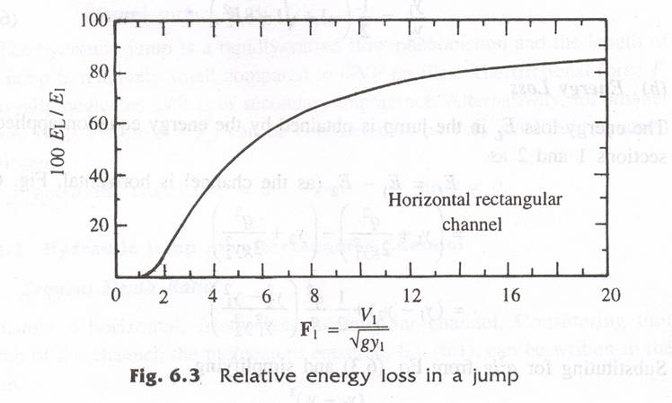

The hydraulic jumps in horizontal rectangular channels are classified into five categories based on the Froude number F_{r1} of the supercritical flow, as follows:
(i) Undular Jump: 1.0< F_{r1} < 1.7
The water surface is undulating with a very small ripple on the surface. The sequent-depth ratio is very small and E_{L}/E₁ is practically zero. A typical undular jump is shown in Fig (a)
.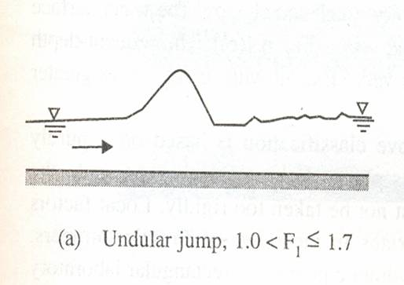 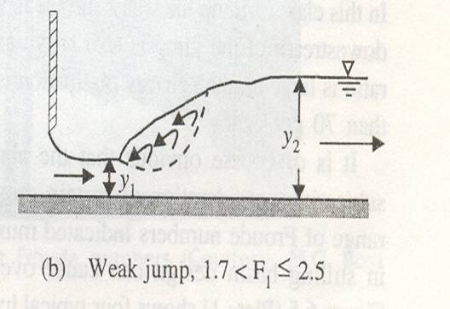 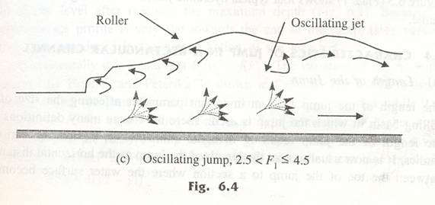

(ii) Weak jump: 1.7< F_{r1} < 2.5
The surface roller makes its appearance at F_{r1 ≈} 1.7 and gradually increases in intensity towards the end of this range, i.e. F_{r1 ≈} 2.5. The energy dissipation is very small, E_{L}/E₁ is about 5 per cent at F_{r1} = 1.7 and 18 per cent at F_{r1} = 2.5. The water surface is smooth after the jump (Fig. (b)).
(iii) Oscillating Jump: 2.5< F_{r1} < 4.5
This category of jump is characterised by an instability of the high-velocity flow in the jump which oscillates in a random manner between the bed and the surface. These oscillations produce large surface waves that travel considerable distances downstream (Fig.(c)). Special care is needed to suppress the waves in stilling basins having this kind of jump. Energy dissipation is moderate in this range; E_{L}/E₁ = 45 per cent at F_{r1} = 4.5.
(iv) ‘Steady’ Jump 4.5< F_{r1} < 9.0
In this range of Froude numbers the jump is well-established, the roller and jump action is fully developed to cause appreciable energy loss (Fig. (d)). The relative energy loss E_{L}/E₁ ranges from 45 per cent to 70 per cent in this class of jump. The ‘steady jump is least sensitive in terms of the toe-position to small fluctuations in the tail water elevation.
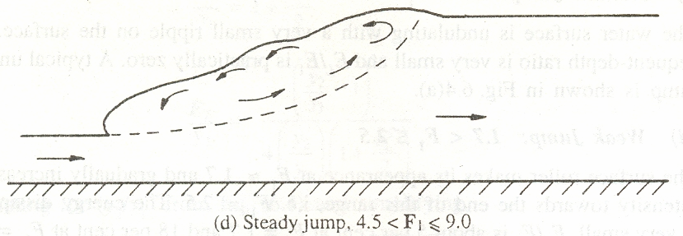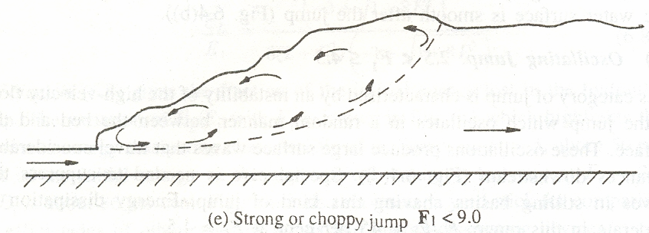
v) Strong or Choppy Jump: F_{r1} > 9.0
In this class of jump the water surface is very rough and choppy. The water surface downstream of the jump is also rough and wavy (Fig. (e)). The sequent-depth ratio is large and the energy dissipation is very efficient with E_{L}/E₁ values greater than 70 per cent.

(b) A rectangular horizontal channel of 5.0 m wide carries a discharge of 20 m³/s. Determine whether hydraulic jump may occur at an initial depth of 0.75 m or not. If jump occurs determine the sequent depth, energy loss percentage with respect to energy at upstream and length of jump. (5)
V1 = 20/(5*0.75) = 5.3333 m/s
Fr1 = V1/sqrt(g*y1) = 1.9662
Weak jump occurs.
$\frac{y_{2}}{y_{1}}=\frac{1}{2}\left(−1+\sqrt{1+8∗1\text{.}{\text{9662}}^{2}}\right)$ = 2.3252
y₂ = 2.3252 * 0.75 = 1.7439 m
$$\frac{E_{L}}{E_{1}}=\frac{{\left(−3+\sqrt{1+8F_{1}^{2}}\right)}^{3}}{8\left(2+F_{1}^{2}\right)\left(−1+\sqrt{1+8F_{1}^{2}}\right)}=\frac{{\left(−3+\sqrt{1+8∗1\text{.}{\text{9662}}^{2}}\right)}^{3}}{8\left(2+1\text{.}{\text{9662}}^{2}\right)\left(−1+\sqrt{1+8∗1\text{.}{\text{9662}}^{2}}\right)}$$
E_{L}/E₁= 0.0853 (ie ) 8.53 %.
Length of the jump : Since Fr1 number is less than 5.0.
L_{j} = 6.9 (y2-y1) = 6.9*(1.7439-0.75) = 6.8579 m

