Dr. Mahalingam College of Engineering & Technology
Pollachi- 642003

ASSIGNMENT– 2 – Questions & Answers

Class & Branch : II B.E. - CIVIL Max. Marks : 100
Sub Name : APPLIED HYDRAULIC ENGINEERING Time : 3 hrs
Semester : IV Assigned Date : 23-MAR-2009
Due Date : 23-MAR-2009
Venue : B308
Answers released date : 01-APR-2009
PART – A (11 x 2 = 22 Marks)
Answer all questions :

- What is specific energy in an open channel flow?
$E=y \text{cos}θ+α\frac{V^{2}}{2g}$Energy of open channel flow with respect to the channel bottom is known as specific energy. It is donated as ‘E’ and expressed as

- Explain the ‘equivalent roughness’ in a channel
$n_{e}=\frac{{\left(\sum{n_{i}^{3/2}}P_{i}\right)}^{3/2}}{P^{2/3}}$Equivalent roughness, also called the composite roughness, is represented a weighted average value for the roughness coefficients based on the parts of perimeter (made of different kinds of surfaces) having different roughness coefficients. One type of method of calculating equivalent roughness is given below:

Where n_{i} is the roughness coefficient of the given portion of the perimeter P_{i}.
P = Total pertimeter = $\sum{P_{i}}$
- Define critical and normal depth in an open channel.
Critical depth: Depth corresponding minimal energy E_{c} is called critical depth. For given discharge and given geometry of the channel there will be one critical depth.
Normal depth : The normal depth is defined as the depth of flow at which a given discharge flows as uniform flow in a given channel. The normal depth is designated as y₀, the suffix ‘0’, being usually used to indicate uniform-flow conditions. The channels of the first kind will thus have one normal depth only. This depth depends on the bed slope of the channel.
- Describe first kind and second kind of channels
if the top surface width of water increases or constant with flow depth in any type of the channel s(like trapezoidal, rectangular etc.), then these channels are called first kind channels or channels of first kind. The channels of first kind will have a unique normal depth in uniform flow associated with each discharge.
Channels with a closing top-width can be designated as channels of the second kind. Top surface width decreases with flow depth in these type of channels. Two normal depths are possible for any particular discharge in some cases of flow.

- Define section factor Z and conveyance factor K of the channel?
The expression $A\sqrt{A/T}$ is a function of the depth y for given geometry of the channel and is known as the section factor Z.
At the critical flow condition, y=y_{c} , hence $A_{c}\sqrt{{A_{c}}/{T_{c}}}=\frac{Q}{\sqrt{g}}$.
Thus $Z_{c}=\frac{Q}{\sqrt{g}}$ when it is related to discharge Q.
Conveyance factor K is a measure of the discharge capacity of the cross-section when channel has a unit slope. It is expressed as $K=\frac{Q}{\sqrt{S_{o}}}$ while relating discharge Q. Relating properties of the channel, conveyance is expressed as $K=\frac{1}{n}{\text{AR}}^{\frac{2}{3}}$.
- What are the first and second hydraulic exponents?
First hydraulic exponent: When expressing relationship between section factor Z and flow depth as
$Z^{2}={A^{3}}/T=C_{1}y^{M}$, the exponent M is called first hydraulic exponent.
Second hydraulic exponent: Relating conveyance factor K and flow depth, it can be approximately written as $K^{2}=C_{2}y^{N}$. In this expression ‘N’ is called the second hydraulic coefficient.
- List the conditions for hydraulically efficient and hydraulically most efficient trapezoidal channels.
With the slope, roughness coefficient and area of flow fixed, a minimum perimeter section will represent the hydraulically-efficient section as it conveys the maximum discharge.
Condition for Hydraulically efficient section: When area of section A and side slope m are fixed, the sum of side slope length of the cross-section should be equal to top width of the flow.
Condition for Hydraulically most efficient section: Along with the above condition, m should be equal to 1/√3 ie. Side slope at 60° with the horizontal. Thus the hydraulically most efficient trapezoidal section becomes one-half of a regular hexagon.

- Draw standard lined trapezoidal section and show the salient dimensions.
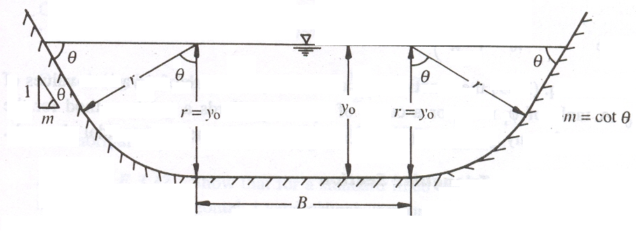

- What is the critical slope in the case of uniform flow?
The slope of a channel which carries a given discharge as a uniform flow at the critical depth is called the critical slope
- What are the possible profiles in a mild sloped open channel flow?
M1 profile - The most common of all gradually varying flow is of M1 type which is a sub critical flow condition. Obstructions to flow such as weirs, dams etc which produce M1 profile. This is also called back water curve.
M2 profile - The M₂ profile occurs at a sudden drop in the bed of the channel in to the ponds or pools or lakes. In a break in grade region from milder to mild slope, this profile is possible.
M3 profile - The M3 profile occurs the flow yielding from a spillway or a sluice gate.

- Explain the control point and its role in GVF.
A control point is defined as any point where there is a known relationship between the depth of flow and discharge. Using the control point, water profile can be obtained by solving the GVF equation.

PART – B ( 6 x 13 = 78 Marks)

- (a) Derive the condition for maximum discharge for a given value of specific energy. (6)
The specific-energy diagram can be plotted for different discharges. Consider a section $\text{PP}'$ in this plot. It is seen that for the ordinate$\text{PP}'$, $E=E_{1}=\text{constant}$. Different Q curves give different intercepts. The difference between the alternate depths decreases as the Q value increases. It is possible to imagine a value of Q=Q_{m} at a point C at which the corresponding specific energy curve would be just tangential to the ordinate PP'. The dotted line indicating the Q_{m} represents the maximum value of discharge that can be passed in the channel while maintaining the specific energy at a constant value. If the Q is more than this Q_{m}, then there will be no intercept on the ordinate for that specific energy.
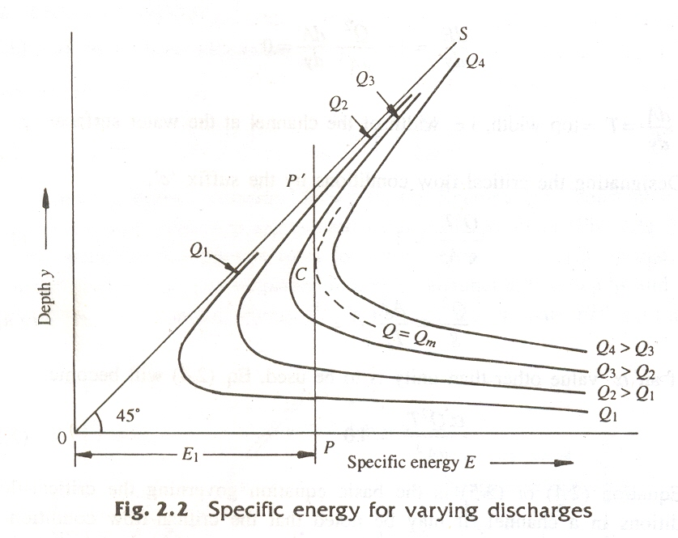
Derivation of condition for maximum discharge for given specific energy
Specific energy $E=y+\frac{Q^{2}}{2{\text{gA}}^{2}}$. . . . . . . . . . . . . . . . . . . . . . . . . . . . . (1)
From Eq (1) $Q=A\sqrt{2g\left(E−y\right)}$. . . . . . . . . .. . . . . . . . . . . . . . . . . (2)
The condition for maximum-discharge can be obtained by differentiating Eq. (2) with respect to ‘y’ and equating it to zero while keeping E as constant.
Thus $\frac{\text{dQ}}{\text{dy}}=\sqrt{2g\left(E−y\right)}\frac{\text{dA}}{\text{dy}}−\frac{\text{gA}}{\sqrt{2g\left(E−y\right)}}=0$. . . . . . . . . . . . . . . . . (3)
From Eq(2), it can be written $\sqrt{2g\left(E−y\right)}=\frac{Q}{A}$ and we know that $\frac{\text{dA}}{\text{dy}}=T$.
Substituting these in Eq(3), we get,
$\frac{Q}{A}T−\frac{\text{gA}}{\frac{Q}{A}}=0$➔ $\frac{Q}{A}T−\frac{{\text{gA}}^{2}}{Q}=0$➔ $\frac{Q}{A}T=\frac{{\text{gA}}^{2}}{Q}$which yields
$\frac{Q^{2}T}{{\text{gA}}^{3}}=1\text{.}0$. This is the condition for the maximum discharge for the given specific energy. It also represents critical-flow condition.

(b) The specific energy for a 6 m wide rectangular channel is 5 Nm/N. If the rate of flow of water through the channel is 24 m³/s. Determine the alternate depths of flow. (7)
6m
Q=24m³/s
E=5 m
B=6 m

Specific energy for the flow is $E=y+\frac{Q^{2}}{2{\text{gB}}^{2}y^{2}}$
Alternate depth can be found for the given specific energy
$5=y+\frac{{\text{24}}^{2}}{2×9\text{.}\text{81}×6^{2}y^{2}}$
$5=y+\frac{0\text{.}\text{8155}}{y^{2}}$
Multiplying both sides by y² and rearranging terms, the following cubic equation is obtained.
$$y^{3}−5y^{2}+0\text{.}\text{8155}=0$$
Solving this cubic equation, the following three values are obtained for y
1). -0.3890 , 2) 0.4220 and 3) 4.9669.
Negative value is practically not possible. So first value not our solution.
So, the alternate depths for the given flow are 0.4220m and 4.9669 m.

- (a) Derive the Chezy’s formula from basic principle for uniform flow through open channel and compare it with manning’s formula. (5)
By definition there is no acceleration in uniform flow. By applying the momentum equation to a control volume encompassing sections 1 and 2, distance L apart, as shown in Fig. 3.1,
$P_{1}+W\text{sin}θ−F_{f}−P_{2}=M_{2}−M_{1}$. Eq(13.1)
where P1 and P2 are the pressure forces and M1 and M2 are the momentum fluxes at section 1 and 2 respectively. W = weight of fluid in the control volume and F_{f} = shear force at the boundary.
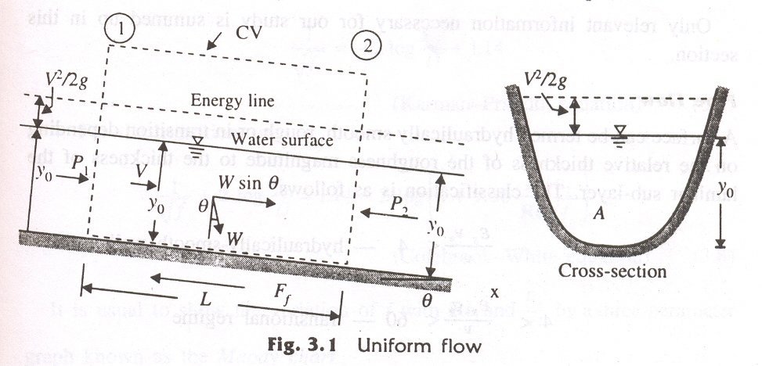
Since the flow is uniform, $P_{1}=P_{2} \text{and} M_{1}=M_{2}$
Also, $W=γ\text{AL} \text{and} F_{f}=τ_{0}\text{PL}$
where $τ_{0}$ = average shear stress on the wetted perimeter of length P and γ = unit weight of water. Replacing $\text{sin}θ$ by $S_{0}$(= bottom slope), Eq. (13.1) can be written as $γ{\text{ALS}}_{0}=τ_{0}\text{PL}$.
Or $τ_{0}=γ\frac{A}{P}S_{0}=γ{\text{RS}}_{0}$ Eq(13.2)
where R=A/P is defined as the hydraulic radius.
R is a length parameter accounting for the shape of the channel. It plays a very important role in developing flow equations which are common to all shapes of channels.
Expressing the average shear stress $τ_{0}$ as $τ_{0}={kρV}^{2}$.
where k is a coefficient which depends on the nature of the surface and flow parameters, Eq. (13.2) is written as
${kρV}^{2}=γ{\text{RS}}_{0}$ leading to $V=C\sqrt{{\text{RS}}_{0}}$. Eq(13.3)
where $C=\sqrt{\frac{γ}{ρ}\frac{1}{k}}$is a coefficient which depends on the nature of the surface and the flow. Equation (13.3) is known as the Chezy formula

(b) Determine the normal depth in a trapezoidal channel with bottom width 40 m and side slope 1 horizontal : 2 vertical when it carries 60 m3/s of water discharge at a bed slope of 1 in 5000. Assume Manning’s roughness coefficient as 0.015. (8)
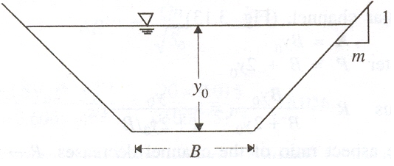
B=40m , Q = 60 m³/s, m=0.5
So = 1/5000 and n=0.015.
Y_{o} = ?

According manning’s formula
$$Q=\frac{1}{n}A\text{.}R^{\frac{2}{3}}\sqrt{S_{o}}$$
Where Q is the discharge, A is the area of flow, R=A/P, P is the wetted perimeter. So, it can also be written as $Q=\frac{1}{n}\frac{A^{5/3}}{P^{2/3}}\sqrt{S_{o}}$
A= (40+0.5y_{o})y_{o} and $P=(\text{40}+2\sqrt{0\text{.}5^{2}+1} y_{o})$=(40+2.2361y)
Substituting value of A, P, Q, n and So.
$$\text{60}=\frac{1}{0\text{.}\text{015}}\frac{(\text{40}+0\text{.}5y_{o})^{5/3}y_{o}^{5/3}}{(\text{40}+2\text{.}\text{2361}y_{o})^{2/3}}\sqrt{0\text{.}\text{0002}}$$
$$\frac{(\text{40}+0\text{.}5y_{o})^{5/3}y_{o}^{5/3}}{(\text{40}+2\text{.}\text{2361}y_{o})^{2/3}}=\text{63}\text{.}\text{6396}$$
Solving the above equation, normal depth 1.3376 m
- Water flows at a steady and uniform depth of 2 m in an open channel of rectangular cross - section having base width equal to 5 m and laid at a slope of 1 in 100. It is desired to obtain critical flow in the channel by providing a hump in the bed. Calculate hump height and sketch the flow profile. Consider the value of Mannings rugosity (roughness) coefficient n = 0.02 for the channel surface. (13)
Hump height ∆Z = ? Need E1, Ec. Connecting formula E1=Ec+∆Z
To find E1, Q is needed. Q can be found from mannings formula as n, yo, B, So are given.
Given data: yo=2 m ; B=5m ; So=.01; n=0.02.
A=10m²; P= 2+2+5 = 9m ; So R=A/P= 10/9=1.1111
Q=(1/n)A.R^{2/3}*(So)^{0.5}
Q=(1/0.02)*10*1.1111^{2/3}*(0.01)^{0.5} = 53.6383 m³/s
$$E=y+\frac{Q^{2}}{2{\text{gA}}^{2}}=2+\frac{\text{53}\text{.}{\text{6383}}^{2}}{2×9\text{.}\text{81}×{\text{10}}^{2}}=3\text{.}\text{4664 m}$$
$$y_{c}={\left(\frac{Q^{2}}{{\text{gB}}^{2}}\right)}^{1/3}={\left(\frac{\text{53}\text{.}{\text{6383}}^{2}}{9\text{.}\text{81}×5^{2}}\right)}^{1/3}=2\text{.}\text{2722 m}$$
Ec = 1.5 yc = 3.4083 m
E1=Ec+∆Z
∆Z=E1-Ec = 3.4664-3.4083 = 0.0581 m
- (a) Determine approximate water surface slope (m per km) at a point in a rectangular channel in which the discharge is 0.84 m³/s, the bed width is 3 m, the depth of flow is 0.75 m and the bed slope is 0.15 m per km. Assume mannings roughness coefficient as 0.02 and take energy coefficient alpha equal to unity. (9)
Given data: Q = 0.84 m₃/s; B=3m; y=0.75m; So =0.00015 m per m. n=0.02
Sw=?,
Need to find Sf , V, A, P, R,.
A=3*0.75 = 2.25 m²; P=3+2*0.75 = 4.5 m; R = 0.5m
V=Q/A=0.84/2.25 = 0.3733 m/s
Sf = n²V²/R^{4/3}= 0.02²x0.3733²/0.5^{4/3} =1.4046x10⁻⁴ m per m
Sw is dy/dx.
$\frac{\text{dy}}{\text{dx}}=\frac{S_{o}−S_{f}}{1−\frac{Q^{2}T}{{\text{gA}}^{3}}}=\frac{0\text{.}\text{00015}−0\text{.}\text{00014046}}{1−\frac{0\text{.}{\text{84}}^{2}×3}{9\text{.}\text{81}×2\text{.}{\text{25}}^{3}}}=$9.7 x10⁻⁶ m per m.
Slope of water profile S_{w} = 9.7x10⁻³ m per km.

(b) A trapezoidal channel with side slope 1:1 and bed slope 1:1000 has a 3m wide bed composed of sand (n=0.02) and sides concrete (n =0.014). Estimate the discharge when the depth of flow is 2.0m (4)
n_{i} =[0.014, 0.014, 0.02];
p_{i}= [2.8284, 2.8284, 3];
n_{e} = sum( (ni.^(3/2).*pi).^(2/3) / sum(pi)^(2/3)
n_{e} = 0.0162
Other Given data : y =2; m = 1; So = 0.001, B=3 m; Calculated equivalent roughness n_{e} = 0.0162.
A = (3+1*2)*2=10 m²; P = 8.6569 m; R = 10/ 8.6569 = 1.1552 m
Q=(1/n_{e})A.R^{2/3}*(So)^{0.5}
Q=(1/0.0162)*10*1.1552^{2/3}*(0.001)^{0.5} = 21.4904 m³/s

- (a)What are the assumptions made to derive the gradually varied flow
from the basic energy equation and derive an expression for water surface slope? (9)
Assumptions made in GVF:
The two basic assumptions involved in the analysis of GVE are:
1. The pressure distribution at any section is assumed to be hydrostatic. This follows from the definition of the flow to have a gradually-varied water surface.
2. The resistance to flow at any depth is assumed to be given by the corresponding uniform-flow equation, such as the Manning’s formula, with the slope term to be used in the equation is the energy slope and not the bed slope.
DIFFERENTIAL EQUATION OF GVF
Consider the total energy H of a gradually-varied flow in a Channel of small slope and α = 1.0 as:
$H=Z+E=Z+y+\frac{V^{2}}{2g}$ where E is specific energy. (16.1)
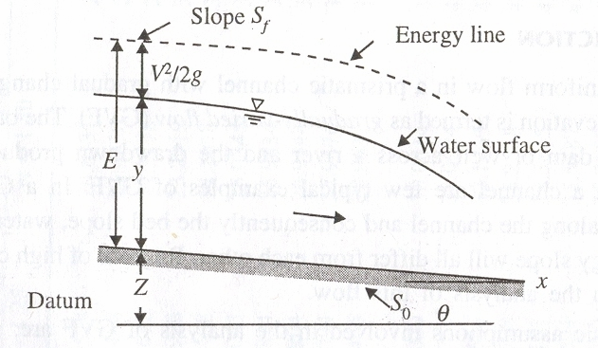
A schematic sketch of a gradually-varied flow is shown in Fig. Since the water surface, in general, varies in the longitudinal (x) direction, the depth of flow and total energy are functions of x. Differentiating Eq. (16.1) with respect to x
$\begin{aligned}\frac{\text{dH}}{\text{dx}}=\frac{\text{dZ}}{\text{dx}}+\frac{\text{dE}}{\text{dx}} \\ \frac{\text{dH}}{\text{dx}}=\frac{\text{dZ}}{\text{dx}}+\frac{\text{dy}}{\text{dx}}+\frac{d}{\text{dx}}\left(\frac{V^{2}}{2g}\right)\end{aligned}$ (16.2)
In this equation, the meaning of each term is as follows:
- $\frac{\text{dH}}{\text{dx}}$ represents the energy slope. Since the total energy of the flow always decreases in the direction of motion, it is common to consider the slope of the decreasing energy line as positive. Denoting it by $S_{f}$ , we have . $\frac{\text{dH}}{\text{dx}}=−S_{f}$. It can be found from mannings formula for a given discharge and geometry.
- $\frac{\text{dZ}}{\text{dx}}$ denotes the bottom slope. It is consider the channel slope with bed elevations decreasing in the downstream direction as positive. Denoting it as $S_{0}$, we have $\frac{\text{dZ}}{\text{dx}}=−S$.
- $\frac{\text{dy}}{\text{dx}}$ represents the water-surface relative to the bottom of the channel.
- $\frac{d}{\text{dx}}\left(\frac{V^{2}}{2g}\right)=\frac{d}{\text{dy}}\left(\frac{Q^{2}}{2{\text{gA}}^{2}}\right)\frac{\text{dy}}{\text{dx}}$$=−\frac{Q^{2}}{{\text{gA}}^{3}}\frac{\text{dA}}{\text{dy}}\frac{\text{dy}}{\text{dx}}$
Since $\text{dA}/\text{dy}=T$, $\frac{d}{\text{dx}}\left(\frac{V^{2}}{2g}\right)=−\frac{Q^{2}T}{{\text{gA}}^{3}}\frac{\text{dy}}{\text{dx}}$

Now, Equation (16.2) can be rewritten as
$−S_{f}=−S_{0}+\frac{\text{dy}}{\text{dx}}−\left(\frac{Q^{2}T}{{\text{gA}}^{3}}\right)\frac{\text{dy}}{\text{dx}}$ and rearranging the same
We get $\frac{\text{dy}}{\text{dx}}=\frac{S_{0}−S_{f}}{1−\frac{Q^{2}T}{{\text{gA}}^{3}}}$.
(b) How dynamic equation of gradually varied flow is simplified in wide rectangular channel? (4)
$\frac{\text{dy}}{\text{dx}}=\frac{S_{0}−S_{f}}{1−\frac{Q^{2}T}{{\text{gA}}^{3}}}$.
In the case of wide rectangular channel
$\frac{Q^{2}T}{{\text{gA}}^{3}}$ becomes $\frac{Q^{2}}{{\text{gA}}^{2}\text{.}A/T}→\frac{Q^{2}}{{\text{gA}}^{2}\text{.}A/T}→\frac{Q^{2}}{{\text{gB}}^{2}y^{2}y}→\frac{q^{2}}{{\text{gy}}^{3}}$
In the case of wide rectangular channel, R approximately becomes y.
Sf can be found from manning’s formula.
$S_{f}=\frac{n^{2}Q^{2}}{A^{2}R^{4/3}}=\frac{n^{2}Q^{2}}{B^{2}y^{2}y^{4/3}}=\frac{n^{2}q^{2}}{y^{{\text{10}}/3}}$.
Substituting the above values in GVF,
$\frac{\text{dy}}{\text{dx}}=\frac{S_{0}−\frac{n^{2}q^{2}}{y^{{\text{10}}/3}}}{1−\frac{q^{2}}{{\text{gy}}^{3}}}$=$\frac{(S_{0}y^{{\text{10}}/3}−n^{2}q^{2}){\text{gy}}^{3}}{({\text{gy}}^{3}−q^{2})y^{{\text{10}}/3}}$=$\frac{(S_{0}y^{{\text{10}}/3}−n^{2}q^{2})g}{({\text{gy}}^{3}−q^{2})y^{1/3}}$
Sf is found from chezy’s formula.
$$S_{f}=\frac{Q^{2}}{C^{2}A^{2}R}=\frac{Q^{2}}{C^{2}B^{2}y^{2}y}=\frac{q^{2}}{C^{2}y^{3}}$$
Substituting the above values in GVF, GVF becomes
$\frac{\text{dy}}{\text{dx}}=\frac{S_{0}−\frac{q^{2}}{C^{2}y^{3}}}{1−\frac{q^{2}}{{\text{gy}}^{3}}}$=$\frac{(S_{0}y^{3}−{q^{2}}/{C^{2}}){\text{gy}}^{3}}{({\text{gy}}^{3}−q^{2})y^{3}}$=$\frac{(S_{0}y^{3}−{q^{2}}/{C^{2}})g}{({\text{gy}}^{3}−q^{2})}$
- How surface profiles of Gradually Varied Flow are classified and explain them with sketches. (13)
Classification of GVF water surface profiles.
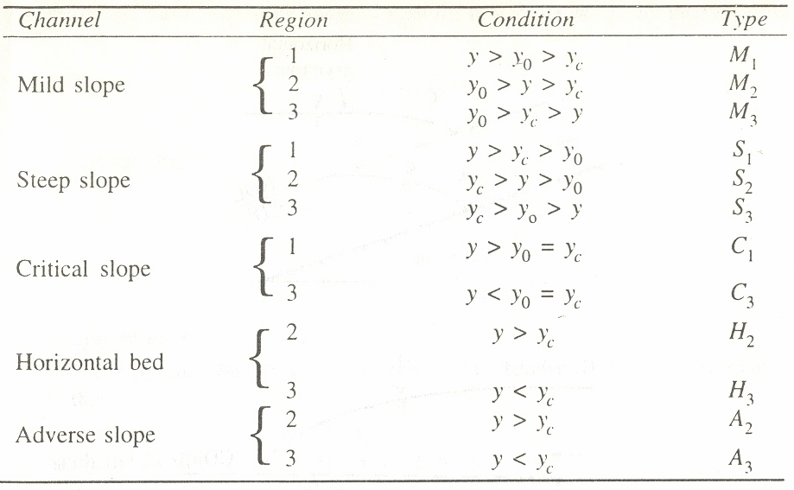
(a) Type M Profiles

The most common of all GVF profiles M1 type, which is a subcritical-flow condition. Obstructions to flow, such as weirs, Dams, structures and natural features, such as bends, produce M1 backwater curves.
The M2 profiles occur at a sudden drop in bed of the channel, at constriction type of transitions and at the canal outlet into pools
The M3 type of profile occurs where a supercritical stream enters a mild- slop channel. The flow leading from a Spillway or sluice gate to a mild slope forms a typical example

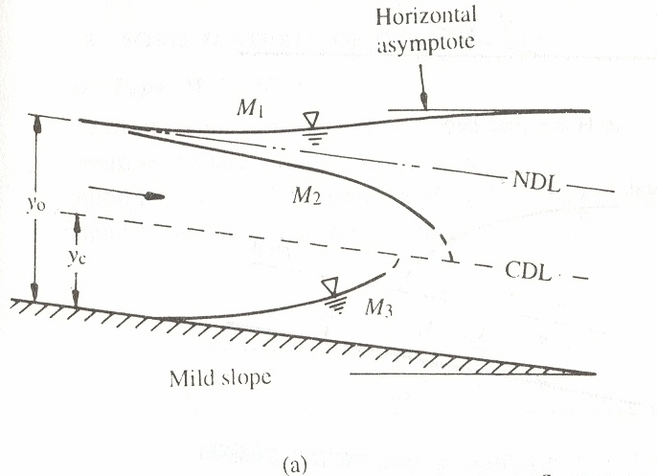
(b) Type S Profiles
The S1 profile is produced when the flow from a steep channel is terminated by a deep pool created by an obstruction, such as a weir or dam. At the beginning of the curve, the flow changes from the normal depth (supercritical flow) to subcritical flow through a hydraulic jump.
Profiles of the S2 type occur at the entrance region of a steep channel leading from a reservoir and at a break of grade from mild slopes to steep slope. Generally S2 profiles are of short length.
Flow profile from a sluice gate with a steep slope on its downstream is of the S3 type. The S3 curve also results when a flow exists from a steeper slope to a less steep slope

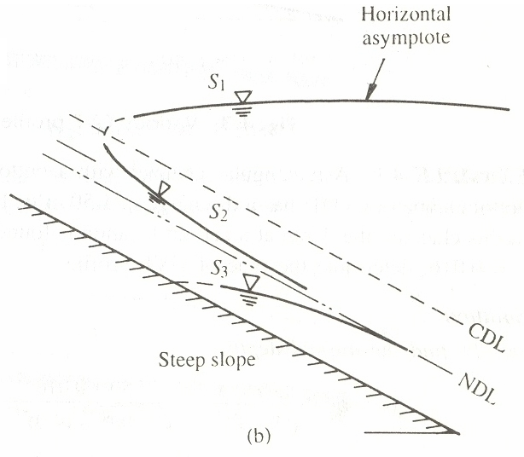

(c) Type C Profiles
C1 and C3 profiles are very rare and are highly unstable.

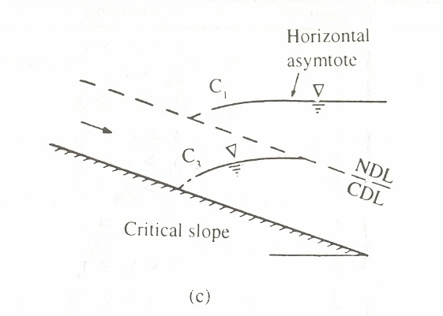

(d) Type H Profiles
A horizontal channel can be considered as the lower limit reached by a mild slope as its bed slope becomes flatter. It is obvious that there is no region 1 for a horizontal channel as yo → ∞. The H2 and H3 profiles are similar to M2 and M2 profiles respectively.

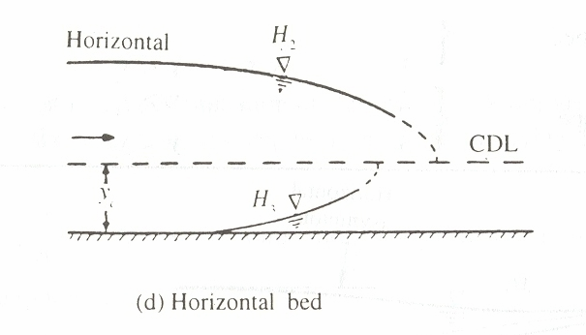

(e) Type A Profiles
Adverse slopes are rather rare and A2 and A3 curves are similar to H2 and H3 curves respectively. These profiles are of very short length.

